Executive Mayor’s Office

Tel 020 7364 4000
mayor@towerhamlets.gov.uk
www.towerhamlets.gov.uk

20 July 2021

Letter to faith communities re: Covid safety

Monday 19 July marks an important step in our response to the Covid-19 pandemic that has dominated our lives for so long. However, it is not Freedom Day, it is not the end of spreading infections, it is not the end of Covid-19 illness. At present, Tower Hamlets continues to have the highest positivity rate in London, and this will not change just because it is 19 July!

We encourage all faith leaders in our borough to act with caution and due care in planning how to move forward in acts of worship and prayer, in celebrations and memorials, so that you continue to protect your congregations and the wider community of Tower Hamlets.

That care may require the continued request for worshippers to wear face masks, to maintain some distance from one another, to use sanitiser, etc. We urge you to think about the particular circumstances of your faith building, and the rituals you perform to maintain good levels of hygiene and protection at this time, particularly for those who are most vulnerable within your communities. So far, we have seen that faith buildings have not been identified as common exposure settings for Covid-19 and it would be advantageous if we could maintain this.

As a council we have told our residents we recommend wearing face coverings in crowded places, council buildings and on public transport to give people the confidence they need to go about their daily lives. While national restrictions are being lifted, we think the government should be encouraging people to continue to wear masks. It’s important to recognise we still have a duty to one another and wearing a mask in certain situations will continue to keep our community safe, particularly those most vulnerable.

At present most national faith organisations have not produced updated guidance. As this becomes available, we will post links to it on both the Council and Inter Faith Forum websites.

In addition, of course, it is vital that you help your congregation overcome any vaccine hesitancy they might have, especially now amongst our young people who are eligible for it.

If you require any support or guidance the boroughs Public Health team are available and can be contacted via email PHCov19@towerhamlets.gov.uk.

Finally we have a low uptake of vaccination in the Borough and therefore we would appreciate your help in spreading the message about how important it is to get vaccinated. Vaccinations protects the individual as we all others from contracting the virus. You can call the Council’s vaccination hotline on 020 7364 3030 to book a vaccination in a venue near you.

We thank you for all that you have done, and continue to do, to serve your congregations and the wider community of Tower Hamlets.
Yours sincerely,
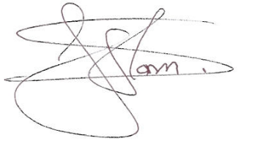
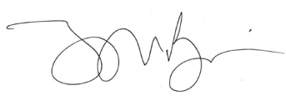

Mayor John Biggs Cllr Sirajul Islam
Executive Mayor of Tower Hamlets Deputy Mayor for Community
Safety, Faith and Equalities

Reverend Alan Green
Chair of Tower Hamlets Inter Faith Forum

