Food, Fuel & Faith 2022: Event Report
Tower Hamlets Inter Faith Forum (THIFF) held an event focused on the cost of living crisis – Food, Fuel & Faith on Thursday 19th May at Bernie Cameron Community Centre in Bow.
The event gathered local residents, faith organisations, council representatives and other VCSE groups to find out how faith and community leaders can support their communities, and the local support that is available in the borough. Attendees enjoyed delicious food, browsed information stalls, and took part in small group discussions.
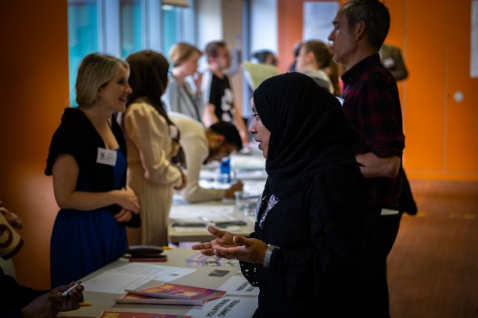
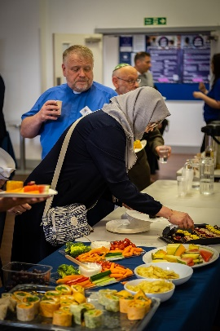
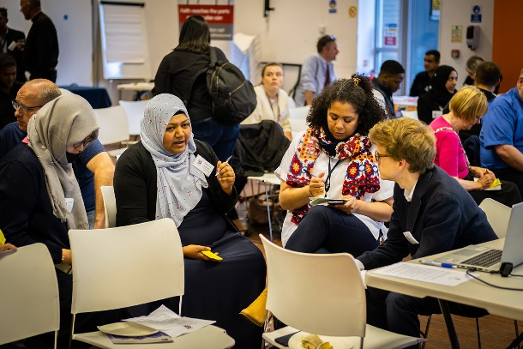

Speakers
Catherine Preece of The Zacchaeus Project, spoke about how the project supports the over 50s with finance and wellbeing
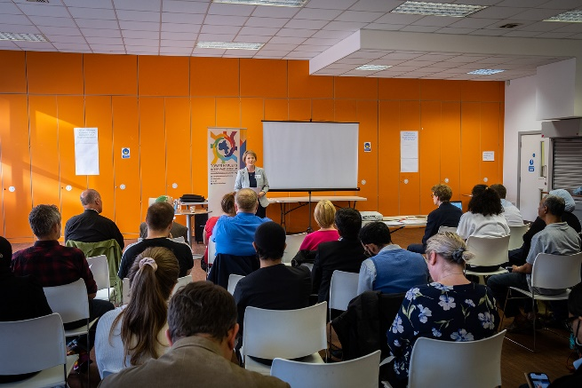
The Zacchaeus Project began in 1999 in Bethnal Green and has two members of staff and 20 volunteers, running a programme of activities all week at the Methodist Church. Many of their membership ask for support with applying for benefits, debt or help with personal budgets, and the team support people with guidance and help. The project often teams up with Quaker Social Action, who advise on how to manage finances. Many of their members need help to access online platforms. Catherine advised other faith groups to have a holistic service and build real relationships with people in order to be able to unpick their situation to offer full support.
Ellie Kershaw of the Tackling Poverty Team at London Borough of Tower Hamlets spoke about the support on offer from the council
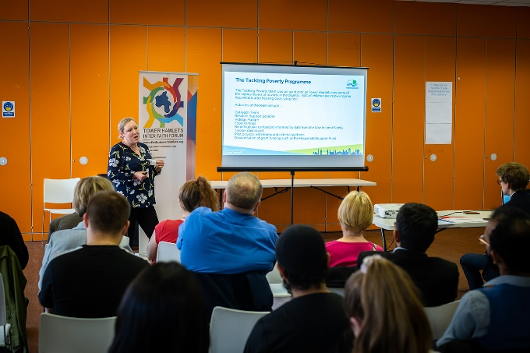
Ellie highlighted the poverty statistics for the borough, as there are 56% of children in low income housing. The council has outreach teams in various parts of the borough, helping people to apply for befits and grants, who also manage a support scheme for people struggling with gas, electric and food costs. There is a limit to how many people can be supported, but the budget for this rose this year to £800,000. The council also run ‘holiday hunger’ programmes, with activities and free food, taking place in summer, and Christmas. The council uses data to identify families with the lowest income and can target information towards these residents. Ellie highlighted the rise in food prices in addition to fuel prices – ‘a perfect storm.’ The council also offer a council tax reduction scheme, and free school meals that are on offer – the outreach teams have recently started working in schools. She advised that faith and community leaders can put people in need in touch with the outreach team, who are happy to arrange an appointment or hold a session. The council have now opened seven food pantries – a version of a foodbank where people pay a small amount to access and then select the food that they want - £3.50 a week can get a round £25 worth of food a week. Please see Ellie’s slides for more information and links.
Shirina Ali, of the Limehouse Project told attendees about the services that they offer to local people
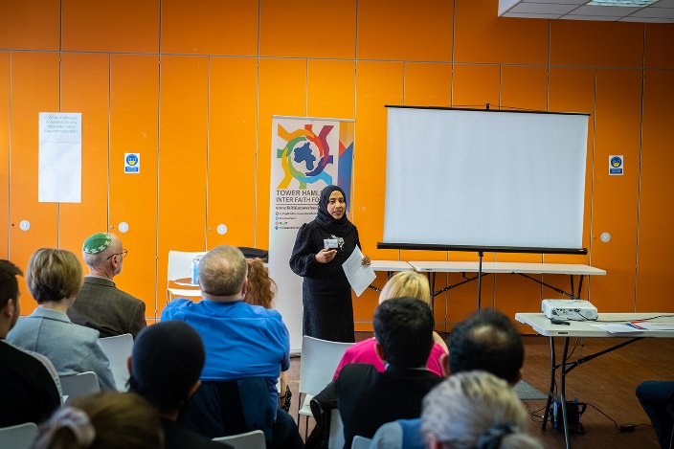
The Limehouse Project was opened in 1983, and is now on Commercial Road, its initial aim was to help parents of children attending a local school. As people found out about the project, more and more wanted their help. The project gives advice about welfare benefits, help maximise income and help people appeal if their benefit application is rejected. They also help families get adequate housing, support people with appeals and have a dedicated Universal Credit advisor. Shirina commented that the project acts as a bridge between residents and the council. The project has several employees and volunteers that help people write CVs and apply for jobs. The project also looks after people’s wellbeing, running luncheon clubs and fitness activities. However, the team are under a lot of demand and have to manage expectations of how much the service can provide.
Josh Clucas & Damien Conrad of the Felix Project spoke about the work the project does distributing food and raising awareness of food insecurity
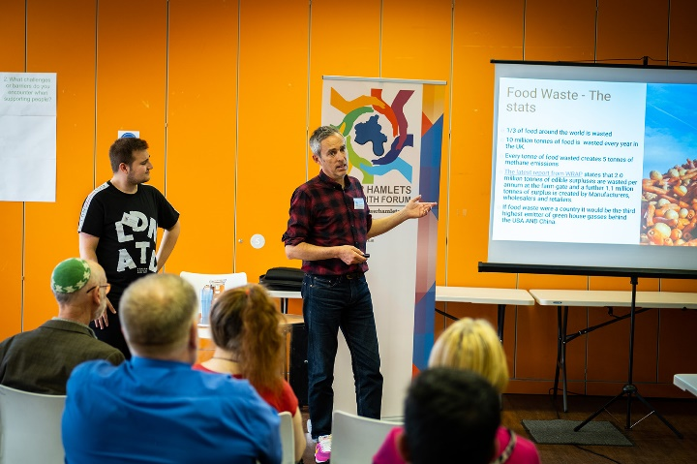
The Felix Project has been running for six years, and focuses on stopping food waste and redistributing it. They take food from everywhere in the food chain, from farm to retail and distribute to 1000 community organisations over London. Felix’s Kitchen is based in Poplar and is entirely dependent on volunteers, preparing many meals a day. The Project also highlights the importance of food education – awareness of nutrition and waste. The Felix Project needs more volunteers – this is essential for creating resilient networks. The Project also appeals for refrigeration space and urge people with space to contact them – the council is willing to fund the cost of a fridge for those with space on their premises. The project is connecting with other local councils to create a connected system – foodbanks are good, but the system needs to be more sustainable. For full details, please see the slides.
Afazul Hoque of London Borough of Tower Hamlets updated attendees on current funding available for faith groups in the borough.
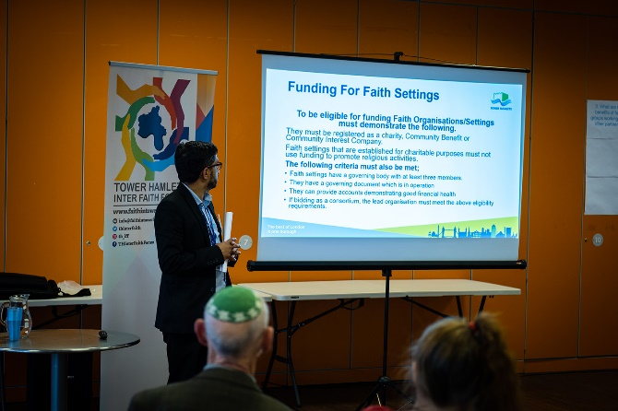
Afazul underlined that to apply for these funding pots, a faith group must be a registered charity, Community Benefit or Community Interest Company. Please see the slides for the full requirements. Funding currently on offer include: LBTH Small Grants Programme, LBTH Innovation Fund (crowdfunding) and LBTH Carbon Reduction Community Grants. Please see the slides for full details. He also pointed out organisations that can help with cost of living issues – THCAN and Tower Hamlets Connect

Discussion
Participants discussed three talking points (see below) in small groups, and then posted their responses on the ‘discussion walls’. These views will pe posted on an interactive page on the THIFF website in due course, with an option for people browsing the site to add their own thoughts. In the meantime, comments included:

- What are the key issues faced by yourself or your community?
“Digital inequalities” “Homelessness and poverty” “Structural inequalities”

- What challenges or barriers do you encounter when supporting people?
“Funding” “Language barriers” “Not knowing all the answers” “Technology”

- What are the benefits of faith groups working with other partners? (What does faith bring to the table)
“Unite people from different communities” “Less judgement of faith centres” “In depth and rounded community knowledge”
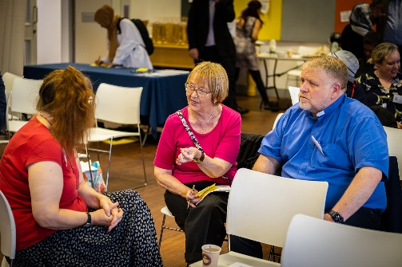
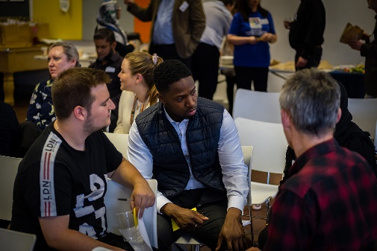
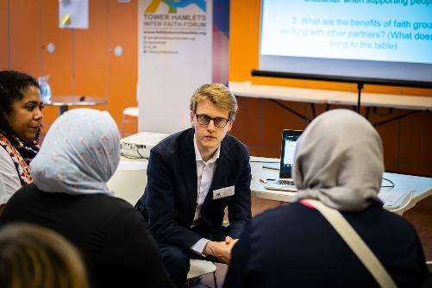

We would like to thank everyone that attended and presented – and a thank you to the Bernie Cameron Community Centre for offering the use of their venue. We feel that this an important conversation that must continue – so please do get in touch if you have any concerns or suggestions regarding this topic.

