Tower Hamlets Working in Partnership 2022: Event Report
In celebration of Inter Faith Week 2022, Tower Hamlets Inter Faith Forum hosted an event on Tuesday 15th November, from 6 – 8pm at Raines Foundation School in Bethnal Green.
The aim of the event was to highlight partnership working in the borough, and hosted by Reverend Alan Green, Chair of THIFF.
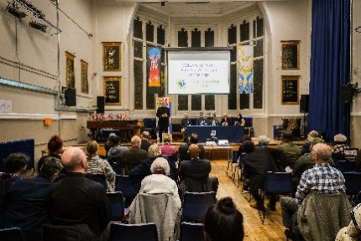
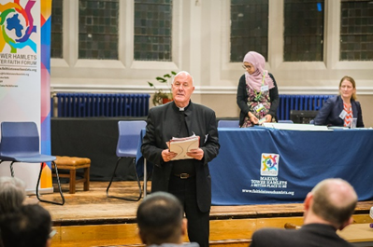
The event gathered local residents, faith leaders, council representatives and other VCSE groups to find out how faith and community leaders can start or build upon partnership working to strengthen relationship and better support the community. Attendees enjoyed delicious food, browsed information stalls, and took part in a feedback activity with Tower Hamlets Council.

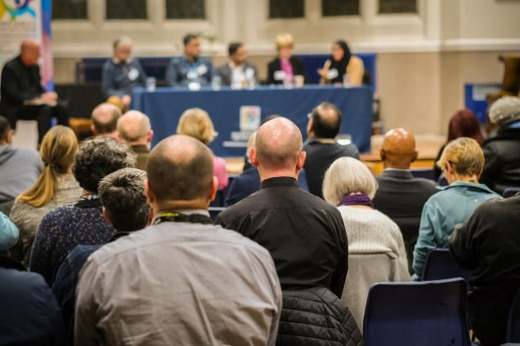
The main part of the event was a panel discussion with guest panellists: The Rt Revd and Rt Hon Dame Sarah Mullally DBE, Bishop of London, Abbas Mirza, Community Engagement Lead at Barts Health NHS Trust, S﻿ufia Alam, Head of Programmes and Maryam Centre at East London Mosque, J﻿on Williams, Engagement and Community Communications Manager at NHS North East London Integrated Care Board and Afazul Hoque, Head of Corporate Strategy & Communities at London Borough of Tower Hamlets. The discussion was led by THIFF Chair, Reverend Alan Green.
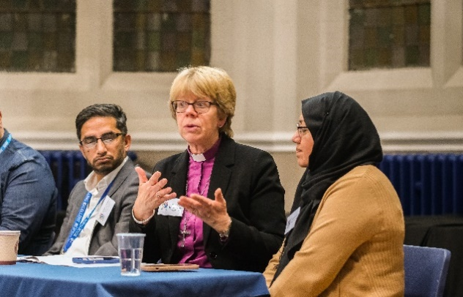
The Bishop of London spoke about the new report, On Faith, Place and Health – and discussed the willingness of faith groups to work in partnership with each other, local government and the NHS to improve health. The report highlights the challenges and lack of information available, but also the opportunity for faith leaders to help with help with this. Also recommendations for the NHS and local authorities, to better develop integration, and the agency for faith leaders to bring about change. Faith groups need to be involved in co design in all areas, not just health. Unless other issues such as minimum wages etc are addressed, health inequalities will always exist.

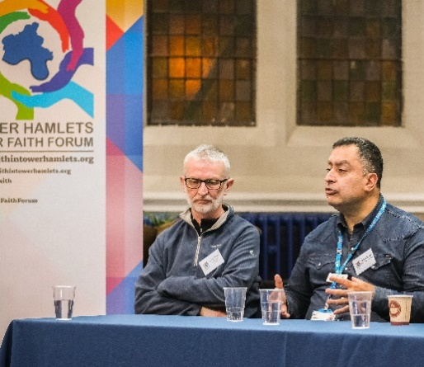
Abbas Mirza discussed how the pandemic brought faith leaders together with the health service. Barts NHS Trust set up a group with local faith groups during this time, and ensured there was an information flow – meeting weekly for two years. The success of the meetings was down to bringing different groups together around the table – and it saved lives. The group still continues to meet.

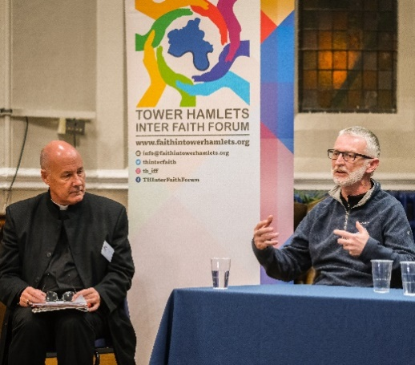
Jon Williams spoke on Tower Hamlets Together – and highlighted the challenge of the cost of living crisis, and the importance of the NHS allocating resources appropriately to local communities. Tower Hamlets Together works to understand the needs and influence, and codesign services across the system. They are aware of the unique links that faith leaders have – the transformation would be working with leaders, and it is a big shift in ways of working. Communities must be involved to provide better services.

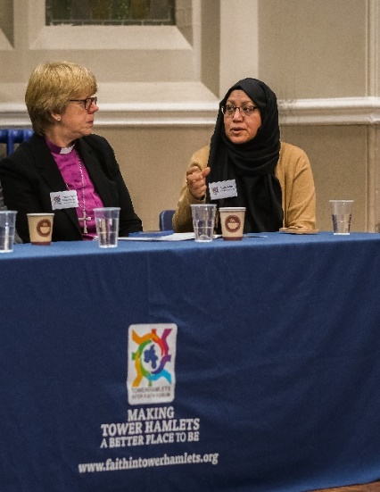
Sufia Alam spoke on the appetite for partnership working – that faith leaders need to be bold enough to have these conversations, but also the need for tangible results from discussions. Having a meaningful conversation can have a big impact – being at the table and negotiating what you need to help local people works.

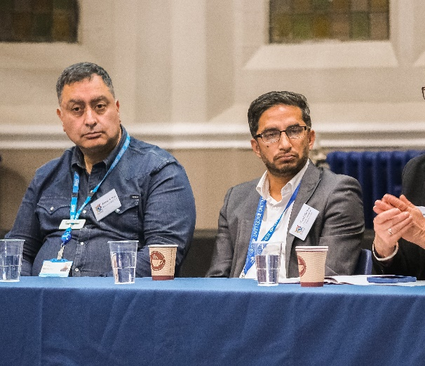
Afazul Hoque discussed the transformation work that is happening across the council – and celebrating the diversity of the borough. It is critical that the council addresses key issues that affect communities and that residents receive information about support on offer. Faith groups have really helped with this and the grants programmes that the council offer can help faith groups extend their support

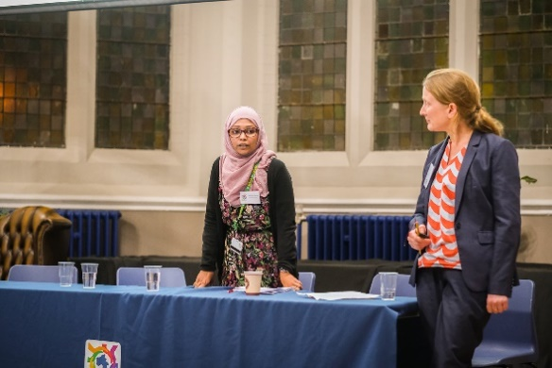
Frances Winter and Abidah Kamali of Tower Hamlets Council then spoke about the Tower Hamlets Partnership Plan, on how they are supporting partners to develop a new vision for the borough – zoning in on key priorities for the borough. The team are holding surveys, engaging with residents and hearing from people. What are hopes, where should we be in ten years’ time, and what can we do together to get there? Attendees then provided feedback in an activity session.
People then browsed stalls, networked and enjoyed refreshments.

