THIFF Forum Meeting Summary: Faith & Funding and AGM
Monday 20 March 2023, 5:30-7:30pm at Tower Hamlets Town Hall

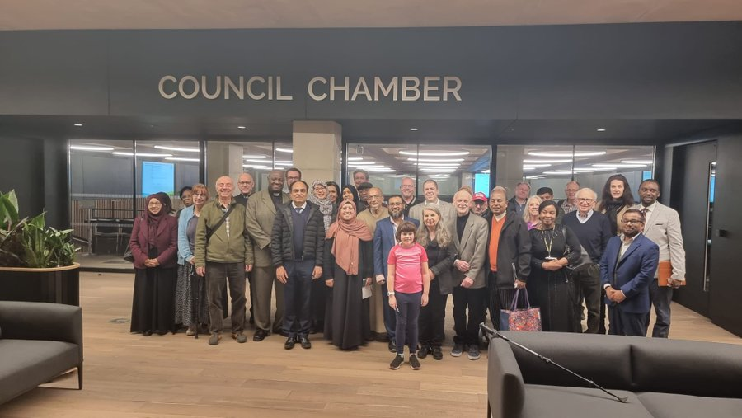

Afazul Hoque, Head of Corporate Strategies & Communities at Tower Hamlets Council opened the meeting, welcoming attendees to the new Town Hall.

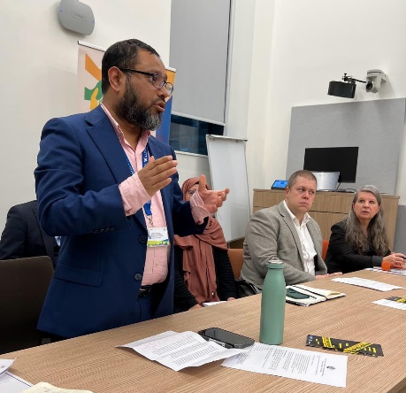
Cllr Maium Talukdar, Deputy Mayor of Tower Hamlets welcomed all, and stated his commitment to working with faith leaders, reflecting on previous success of fighting the EDL, improving safeguarding and noting that faith leaders are the eyes and ears of the community. He spoke of his intention to hold monthly or quarterly roundtable discussions with faith leaders and to get know each other better. He recognised the valuable work done by faith communities during the pandemic, with many people working together to serve the borough.

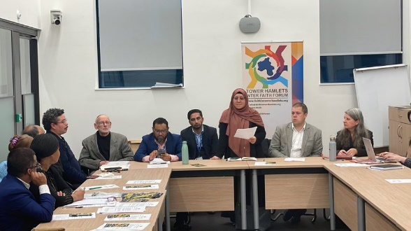
Sufia Alam, Interim Chair of THIFF, also welcomed attendees to the forum meeting, and stated it was nice to see so many people in the room. The aim of THIFF is to break down faith based prejudice and communicate positive change. It works to recognise the contribution that faith makes, develop shared understanding on public issues and ensure the voice of faith is listened to and helps influence local decision makers.
Questions for Deputy Mayor
What are your priorities with regards to inter faith?
A – I have worked with faith based organisations for all of my working life. My priorities are clear, that we all work together, and the council is a platform that provides opportunities and fills the gaps – obviously there are financial implications and would like to support more but there is a pressure. A clear priority is that THIFF should continue and be bigger and better.
Leon Silver, THIFF Steering Group Member addressed the group, speaking on the way that many other forums discuss faith and religious beliefs. THIFF is not like that – we learn about each other’s faith, but the main emphasis is on working together for the better of the community. Tower Hamlets is a big borough, with generations of immigrants, difficulties and racism, but decent people have always stood together and today it represents the best of life in Tower Hamlets.
Leon noted that the intolerant are the exception, we live together as different communities, become friends and become family. All here today represent the best in Tower Hamlets, and stand together so that problems can be alleviated, and views can be expressed.
Jan McHarry – THIFF Steering Group Member commented that THIFF has grown over the years, and she has been involved as a Buddhist representative for about 15 years now and keeps involved to serve the borough and be involved with projects that make life better for residents. THIFF is here to do acts of good that improve quality of life. Jan added that THIFF is going through a period of transition at present when Chair Alan Green retired, and that the meeting today sees new faces and old.

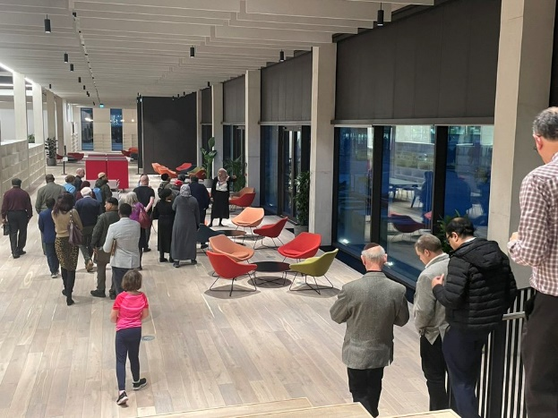
Attendees were then taken for a tour of the new Town Hall, and were able to see the great meeting spaces, the residents hub, and some of the office space in the new building that combines new and old architecture. The group enjoyed refreshments and networking.

Mark Waterman – Senior Development Officer at Tower Hamlets Council, gave a presentation on the new Grants Programme. He outlined the following areas (See slides for full details)
- Tackling the Cost of Living Crisis - advice info, legal rights, immigration and asylum, benefits, legal advice, how to access universal credit and advice support
- Accelerate Education - access learning – language support, extracurricular activities, skills for life, community language development, ESOL, digital inclusion
- Culture, Business, Jobs and Skills - Employment skills for socially excluded – NEET, targeted youth outreach, access youth provision, promote enterprise, job brokerage, promote local culture
- Invest in Public Services - Physical/mental wellbeing for older people – supporting older in lunch clubs, pensioner projects. Developing community activities aimed at tackling inequality.
- Empower Communities and Fight Crime - Inequalities experienced by people and communities – Addressing inequality for Black, Asian and Multi Ethnic communities and women. Creating opportunities for people to come together. Community safety – tackling crime and drugs.
- Small Grants Programme – One off funding for time limited projects including the themes: Mayor’s Youth Empowerment Fund, Mayor’s positive activities for young people, community events, capacity building, community chest.
- Next Steps and Timeline
Following a recent period of engagement, bidding should open in May/April, with grants approved in August.
The Innovation Fund - The Tower Hamlets Innovation Fund is designed specifically to provide match funding support of up to £10,000 (or a maximum of 50 per cent of an organisations crowdfunding target) to organisations based and working in Tower Hamlets. Organisations would need to crowdfund through Spacehive for the remainder of their target.
The deadline for the current round is 29th March 2023.
Find out more about funding and Spacehive here, with a video from Frank Kibble, Partnership Director at Spacehive.
Jonathan Garcia, Development Officer at Tower Hamlets CVS then presented on support available for faith groups (see slides for full details), highlighting:
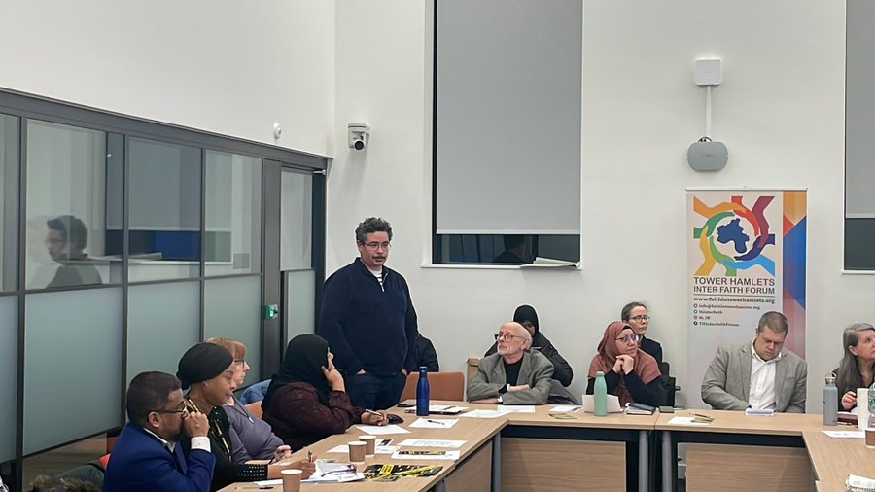
- THCVS have inclusive membership, coproducing change and offering a variety of resources.
- Offering faith groups advice, training, workshops and resources.
- Funders want projects with a community benefit with identified needs
- Comment from attendee – CVS is very constructive, very helpful. Support is excellent.
AGM
Daniel Range, of Coventry University introduced the AGM section of the meeting. He explained that FaithAction and Coventry support THIFF to operate and plan forward. Historically there were only four members of the steering group, but the group is looking for more people to step forward as candidates. All existing members have stepped down for the AGM process.
Results – Sufia Alam was voted back in as Interim Chair for the next six months, and Jan Mc Harry and Leon Silver as steering group members until the next full AGM. There will be an extraordinary AGM in six months.
Candidates that stepped forward (some apologies received – others that showed interest are being contacted outside of the meeting)
Rev James Olanipekun, Pastor of Christ Apostolic Church, resident for almost forty years and Chair of Mile End Ward Panel and Ambassador at Poplar HARCA.
Saleha Islam, Canary Wharf Chaplaincy, born and raised in the borough, a faith leader of five years and keen to give women a voice.
Sigrid Werner, a frequent THIFF attendee for twenty years, a Christian minister by training trustee at Friends of Tower Hamlets Cemetery Park, and on the committee of German Lutheran church, works and lives in the borough.
Are you interested in expressing an interest in joining the steering group? See here for more details
Other:
Emdad Talukder MBE raised awareness of the Tower Hamlets Fostering Team – his main role is to promote fostering in wider community – working with mosques, schools, GP services etc. Many religious people think you have to foster a child of the same religion. Anyone can foster with any background. Please raise awareness of this.
Faz Ali, a research fellow at University College London highlighted her work addressing covid vaccine hesitancy in faith groups – looking for people to take part in an inter faith workshop. Leaflets were distributed.
Benedicta Dikeocha, Hate Crime Projects Officer at Tower Hamlets Council is a support service for anyone that has encountered hate crime. Find out more about their services here.
Sufia Alam then closed the meeting, thanking people for attending and wished people a peaceful Ramadan.
The next forum meeting will take place at 6pm on Monday 5th June – look out for further details!

