THIFF Forum Meeting Summary: Emerging Council Priorities
Monday 5 June 2023, 6-8pm at London Muslim Centre/Teams

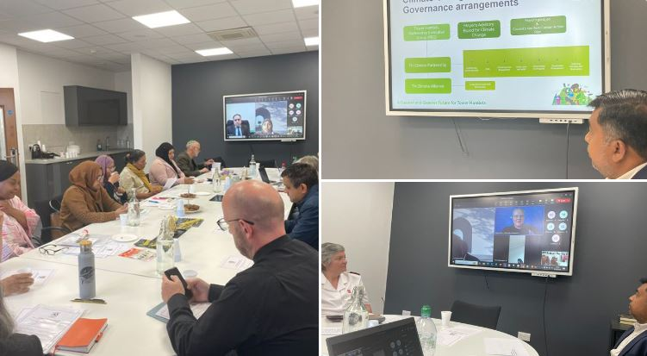

THIFF Interim Chair, Sufia Alam, East London Mosque
- Welcomed attendees both in the room and online.
- Updates on the expansion of the THIFF Steering Group, outlining plans for inducting new members
- Made attendees aware of THIFF’s presence at the upcoming Festival of Communities

Lima Khanom, Domestic Abuse Intervention & Prevention Coordinator, VAWG and Hate Crime Team at London Borough of Tower Hamlets
- Highlighted the importance of people from all backgrounds getting help for domestic violence
- Works with both victims and professionals
- Training is available; covering what domestic abuse is, what a non-abusive relationship looks like, what people are entitled to (both legal and civil), how to access support, and how to signpost others
- Sometimes people feel uncomfortable addressing the situation, but 95% of people would like to be asked
- Tower Hamlets Enforcement Officers (THEO) are also trained to be aware of referring domestic abuse incidents.
- Team visits community centres, and there is an information bus that can be parked up to offer advice to parents and teens nearby schools.
- Other work includes faith centres and educating leaders, East London Mosque have been involved with this.
Q - How long is the training?
A They offer a two hour training session for professionals, and two hours over three weeks for members of the community.
Q - Have local police officers had training?
A - Only THEOs, not officers as yet in Tower Hamlets
Comment – Account 3 have produced videos on domestic violence with local women, produced in English with Bangla and Somali subtitles. Contact Cherifa Atoussi at cherifa.atoussi@account3.org.uk if you would like to share them.
Comment – I have attended a training session and learnt how to spot signs of abuse. This is something that organisations are increasingly aware of.
To contact Lima, please email Lima.Khanom@towerhamlets.gov.uk or call 020 7364 4789 or 07958 715 894

Abdul Khan, Head of Sustainability at London Borough of Tower Hamlets
- There is much more awareness of the topic of sustainability in recent times, people want to tackle climate change.
- Mayor Rahman set addressing climate change as a main priority and chairs a Mayors Advisory Board for Climate Change. The board includes community members and businesses.
- The group has been running for about a year and the aim id to set up a climate change alliance, bringing all stakeholders together – if people are interested in finding out more, they can contact Abdul.
- The Mayor has pledged initiatives including making the council carbon neutral, making homes energy efficient, tackling air pollution, and working with private and social landlords to improve insulation standards in homes.
- The council are aiming for net zero carbon in a number of ways. Schools have received funding to carry out energy efficiency works, there is a boiler replacement programme, and SME Energy Efficiency Grants Programme.
- Through the Carbon Energy Fund, the council has successfully delivered: sustainability education packs, a boiler replacement programme, schools carbon emission reduction, schools energy retrofit programme, SME energy efficiency grants programme and a public sector retrofit.
- The council will continue to deliver the following: Renewable Energy Efficiency Project, Bio-solar Project, Assisted housing refurbishment, community tree planting and Carbon Reduction Community Grants – 100% funded grants to community groups and charities to carry out energy retrofit, renewable and behaviour change projects.
- Retrofit London is a collaborative programme being led by London’s local authorities which will achieve mass home retrofitting to achieve an average Energy Performance Certificate Level of B by 2030.
Q – How we can we get in touch about grants or other opportunities?
A – You can find out more about grants by emailing THEnergy@towerhamlets.gov.uk or email Abdul.Khan@towerhamlets.gov.uk
Q – What help is there for social housing that has problems with mould etc?
A – Landlords have a legal duty to ensure homes are fit for purpose. If in doubt, contact the housing provider, e.g. Tower Hamlets Homes. For issues with privately rented housing contact the landlord in the first instance, or the council’s environmental health team if need be
Q - Is there support for groups to apply for the community grants?
A – Yes, when the funding is live there will be support available, but the process will be straightforward.
Q – There is no promotion of ways to recycle on housing estates. Are there any plans for original ideas to encourage people and raise awareness? Such as a prize for the block that recycles the most?
A – This will be fed back to the recycling team, Lewisham area has success with a similar initiative.

Updates from attendees
Mark Bell, Canary Wharf Multifaith Chaplaincy – They are looking for volunteer chaplains to serve the retail community at Canary Wharf, to offer pastoral support. You can get in touch at talktous@canarywharfchaplaincy.co.uk
Jonathan Garcia, Tower Hamlets CVS – CVS are running a survey on State of the Sector. The survey finding will aim to understand current challenges of the sector, address the situation by advocating to statutory partners and funders and respond with appropriate support. You can find out more and fill in the survey here.
Sister Christine Frost, Neighbours in Poplar – Highlighted the plight of isolated older people and shared a petition around the treatment of illegal immigrants.
Note – Met Police joined the meeting online for their section but had technical difficulties, we hope to circulate an update from them in due course. Patricia Buddington of LIFT Futures also could not join due to unforeseen circumstances.

