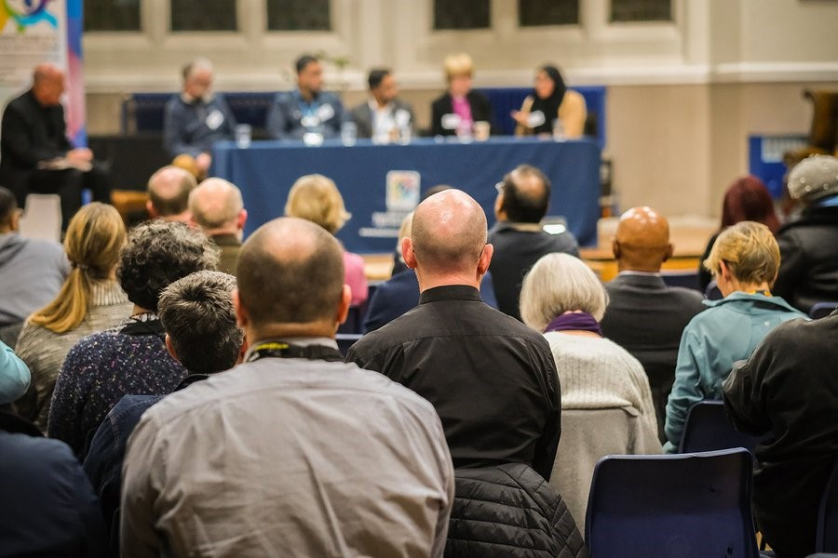

Tower Hamlets Inter Faith Forum

Annual Report, 2022-2023

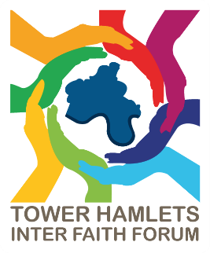

Contents
1. Forewords 3
1.1 Foreword from the THIFF Steering Group 3
1.2 Foreword from London Borough of Tower Hamlets Council 3
2. About this report 5
3. About THIFF 6
4. Vision and Manifesto 8
5. Structure, Governance and Management 10
6. THIFF Achievements and Activities 2022-2023 11
6.1 Forum meetings 11
6.2 Interfaith events 14
6.3 Collaboration and partnership working 19
6.4 Project Work 20
6.5 Other outcomes 22
7. Looking Forward 23

To contact THIFF, please email info@faithintowerhamlets.org

Forewords

Foreword from the THIFF Steering Group
Welcome to the THIFF 2022-2023 Annual Report.
We are one of the many faith-based social action organisations and activities that play a valuable role in serving the diverse communities in Tower Hamlets and are pleased and proud to have worked across the borough with partners, old and new, over the last year. Whilst many of these partners and activities are an extension of what some may regard as more traditional faith practices, the pandemic taught us their impact on everyone in the borough is important and cannot be denied. They do make a real difference to people’s lives and they bring hope. Just as decision-makers need to view THIFF as an active partner and not just a client, outgoing THIFF Chair, Revd. Preb. Alan Green also reminded us that many opportunities exist for faith communities to “be far more open about your work” too.
The year continued to be a time of substantial uncertainty. With Covid-19 still impacting local services, rising energy and food prices and political change locally and nationally, there was no let-up in the challenges facing the borough. For THIFF too it was a period of transition as we said goodbye to Rev. Preb. Alan Green (moving to pastures new) and welcomed Sufia Alam, Head of Programmes at the Maryam Centre, London Muslim Centre as Interim Chair of THIFF. Gratitude to both for their unbounded energy and vision.
—THIFF Steering Group; Sufia Alam, Jan McHarry, and Leon Silver

Foreword from London Borough of Tower Hamlets Council
Tower Hamlets is home to communities of all the world’s great faiths and there is a growing understanding of the contribution of faith communities to the life of our residents. For many years, new communities have settled in Tower Hamlets because of the opportunities to trade, do business and raise their families, creating a vibrant and diverse borough. One of our biggest strengths is our proud history of fighting racism and fascism and our continued commitment to diversity. Our aspiration is to celebrate our diverse communities as a key asset.
This means collaborating with partners to have a positive impact on residents and support them to reach their potential in all areas. The Tower Hamlets Interfaith Forum is a key local partner bringing together a diverse range of faith groups to collaborate and celebrate our faith communities.
As a council we value and support the work of the Inter Faith Forum in bringing communities together, learning and understanding of the shared religious values that cut across all faith, and none, and creating a Forum that also looks at the challenges residents of all faith and non-have been working through. The aim of these discussions is to make recommendations to local agencies, based on equality and inclusion. The Forum encourages respect towards others and a focus on mutual understanding and action. The Forum is not a platform for theological debates, extremist views, or for undermining any religion or belief, rather a place of finding solutions to the issues that face all residents guided by our values.
It has been a pleasure to work closely with the Forum including hosting a visit to our New Town Hall. I look forward to continuing this vital work to ensure the voices of faith groups in the borough are heard and impact local policy and decision making.
—Councillor Maium Talukdar, Deputy Mayor and Cabinet Member for Education, Youth and Lifelong Learning (Statutory Deputy Mayor),
London Borough of Tower Hamlets

About this report
This Annual Report covers activities and achievements of THIFF in the reporting period of the 2022 to 2023 financial year. This is April 1st 2022 to 31st March 2023.
Sections 3, 4 and 5 of the report introduce THIFF, our vision and our structure whilst Section 6 details the works, events and meetings undertaken and hosted by THIFF over the last year. Finally, Section 7 is an opportunity to look forward to activities and areas of work that will take place in the remainder of 2023. Throughout the document are links to the THIFF website and other resources that the Forum makes available.

About THIFF
Tower Hamlets Inter Faith Forum exists to celebrate the significant contribution that faith organisations play in the lives of Tower Hamlets residents, and to facilitate better communication and understanding between different faiths in the borough. The forum meets every two months and is led by a small steering group.
The Tower Hamlets Inter Faith Forum in Tower Hamlets provides a great opportunity to celebrate the significant contribution that faith organisations have in the lives of people in Tower Hamlets. It provides the space to identify how faith organisations can play an even bigger role in the future success of all communities who live and work here.
One of the most important roles of the Inter Faith Forum is to facilitate better communication and understanding between the different faiths in Tower Hamlets. In the current international climate, this role is a vital one.
The Inter Faith Forum has set itself an ambitious agenda and to achieve this is working closely with a large number of faith leaders representing the broad range of faiths in the borough, as well as the Council, the Police and local umbrella and network bodies.
By drawing together all the faith organisations in Tower Hamlets, the forum aims to:
- celebrate the important contribution that religious faith makes to the lives of local communities
- foster greater understanding and respect between our communities
- secure a more prominent role for faith organisations in regenerating their communities and delivering the borough’s community plan
- provide a forum for sharing knowledge, resources and good practice
- speak with and in harmony when faith organisations address important public issues
- break down prejudice and discrimination based on faith
THIFF aims to make getting involved in Tower Hamlets Inter Faith Forum and associated activities a rich and rewarding experience for all. Individuals and organisations are welcome to join us at forums and events, our only criteria being that you are respectful of others’ views. We also actively welcome content suggestions and contributions for forum meetings and recent forum meeting themes were set following consultation with local residents.
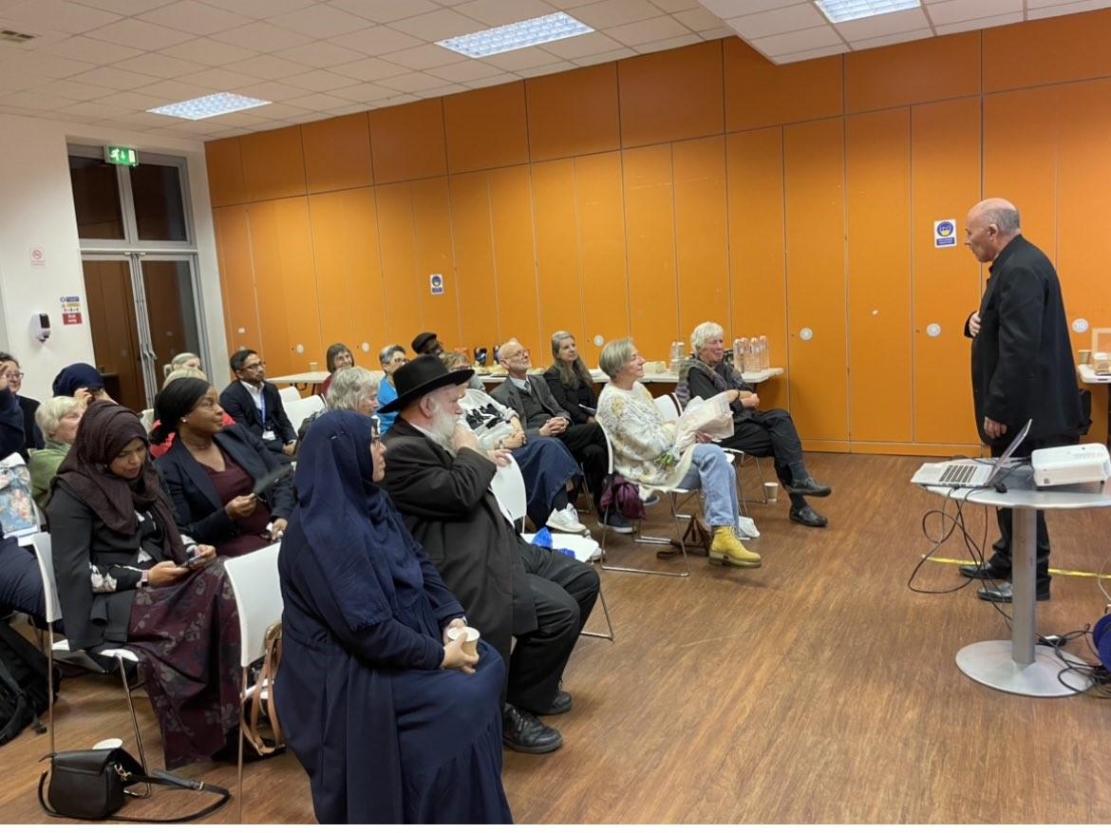
THIFF is a member of the Inter Faith Network for the UK (IFN). IFN works to build good relations between people of different faiths and beliefs, promoting mutual respect and understanding. Additionally, IFN also disseminates advice, support, information and best practice to support interfaith relations across the country.

Vision and Manifesto
THIFF aims to make Tower Hamlets a better place to be. This inclusive aim extends to all in the borough, whether they are residents, working in the borough, studying in the borough or using amenities in the borough and whether they are of faith backgrounds or not.
This aspiration was articulated via a Theory of Change workshop with Coventry University in 2017 and has been updated and re-checked annually since. The Theory of Change document (Figure 1) shows that the activities which THIFF undertakes lead up to logical outcomes which, when combined, contribute towards the aim of making the borough a better place to be. These activities include:
- Interfaith advocacy and leadership
- Partnership support and collaborative action
- Running and attending events and promoting dialogue
- Awareness raising
- Internal development, communication and promotion
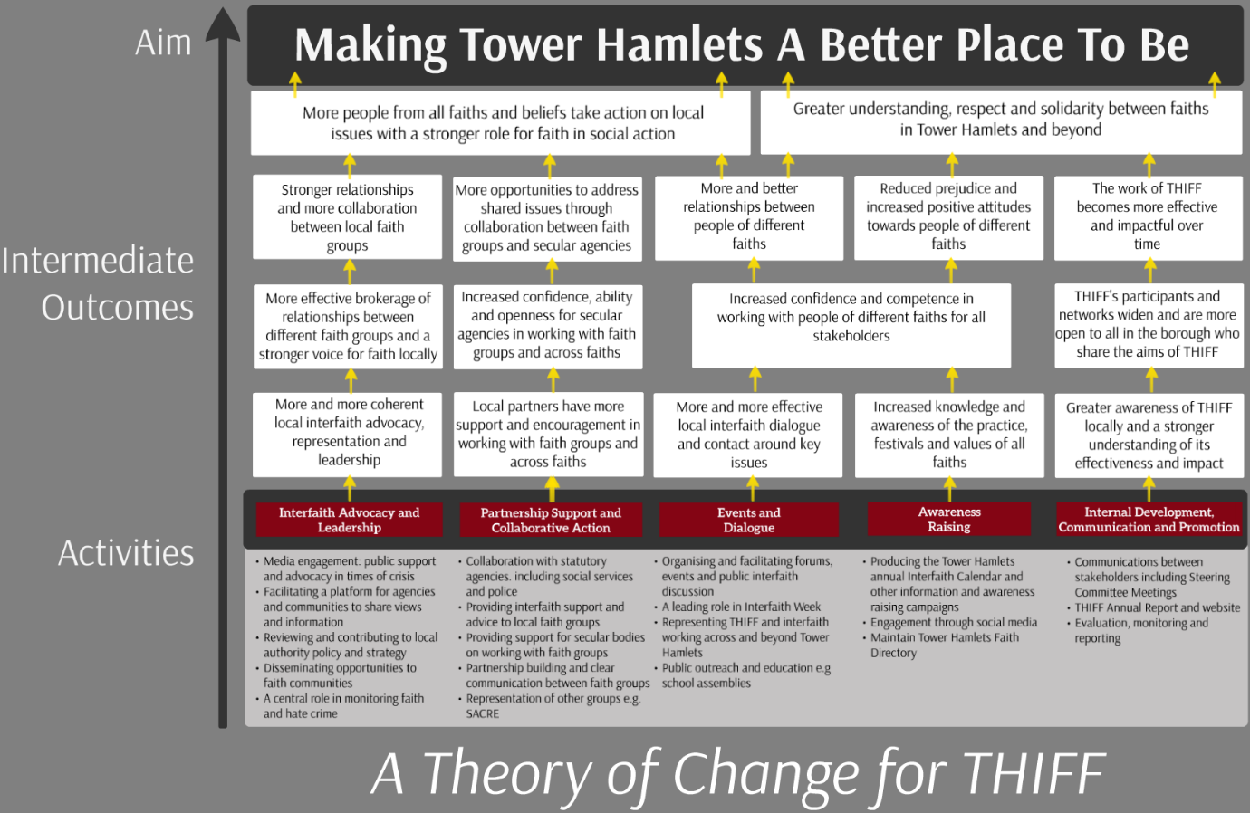
Figure 1: A Theory of Change for THIFF, 2023

In February 2018 THIFF issued a Manifesto as a call to action for those already working for and with THIFF, in whatever capacity, but also for those who share the aims and ambitions of ensuring that the religion and belief sector can play a full role in making Tower Hamlets a better place to be.
The THIFF Manifesto can be found in full at https://www.faithintowerhamlets.org/info/manifesto/

Structure, Governance and Management
There is no formal membership of THIFF and meetings and events are open to all. The only criteria for attending and taking part is that you are respectful of others’ views. THIFF is run by a small steering group and elections to this steering group are held at the THIFF AGM. An AGM was held in the reporting period of this report on the 20th March 2023.
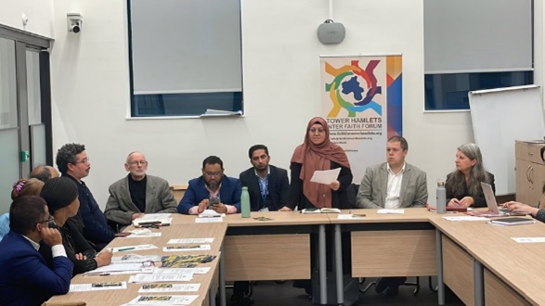
At the AGM Sufia Alam was voted back in as Interim Chair for the next six months, and Jan Mc Harry and Leon Silver as steering group members until the next full AGM. There will be an extraordinary AGM in six months. This extraordinary AGM will see the Steering Group expanded to include new members who have expressed an interest. The Steering Group will be working with these individuals through summer 2023.
Since 2017, with funding provided by Tower Hamlets Council, the Centre for Trust, Peace and Social Relations at Coventry University and FaithAction, a national network of faith-based and community organisations seeking to serve their communities through social action, have been working with THIFF to manage the forum and deliver local events.
THIFF is now also an active member of the TH Equalities Hub. This Hub is a central part of London Borough of Tower Hamlets new direction for equalities provision and provides a central strategic focus, responding to the community’s needs and issues. The hub is run and co-ordinated by Tower Hamlets CVS and is key to bringing about a more coordinated approach to equalities in the borough. The Hub website can be found here:
http://thequalitieshub.org.uk/

THIFF Achievements and Activities 2022-2023
This Annual Report covers activities and achievements of THIFF in the reporting period of April 1st 2022 to 31st March 2023.
Activities and achievements are split thematically based on the work undertaken by the forum.

Forum meetings
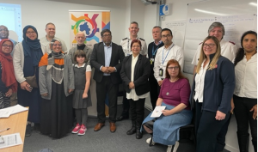
THIFF aims to meet as a public forum every 2 to 3 months. In 2018 the decision was made to hold forum meetings all round Tower Hamlets borough rather than using the same venue for all meetings. This gave greater access to the forum for residents and, where possible, Forum meetings have been held using a hybrid model to allow participants to join in online.
Minutes for previous meetings can be found here:
https://www.faithintowerhamlets.org/info/meetings/
Here, in chronological order, are the details of all THIFF forum meetings covered by this Annual Report reporting period:
Date | Theme | Key speakers | Venue
13/06/2022 | Supporting people from Ukraine and Refugees | Bethan Lant, Praxis  Pascale Robinson, Praxis  Rev. Georgina Stride, Shoreditch Tabernacle Church  Nazrul Hannan, Metropolitan Police | The Green House 244-254 Cambridge Heath Road
12/09/2022 | This Forum meeting was cancelled as it fell within the national mourning period for Queen Elizabeth II
30/01/2023 | Safer Communities | Superintendent Andy Port, Neighbourhood Policing, Central East – Hackney and Tower Hamlets  Krzystof Rycerz, Hate Crime Officer, Central East – Hackney and Tower Hamlets  Councillor Ohid Ahmed & Charles Griggs, on Safer Communities - London Borough of Tower Hamlets  Abidah Kamali - Tower Hamlets Partnership Plan, London Borough of Tower Hamlets | The Green House 244-254 Cambridge Heath Road
20/03/23 | Review of Faith Funding and AGM | Afazul Hoque, Head of Corporate Strategies & Communities at Tower Hamlets Council  Cllr Maium Talukdar, Deputy Mayor of Tower Hamlets  Sufia Alam, Interim Chair of THIFF  Mark Waterman – Senior Development Officer at Tower Hamlets Council  Jonathan Garcia, Development Officer at Tower Hamlets CVS | London Borough of Tower Hamlets, Town Hall, 160 Whitechapel Road

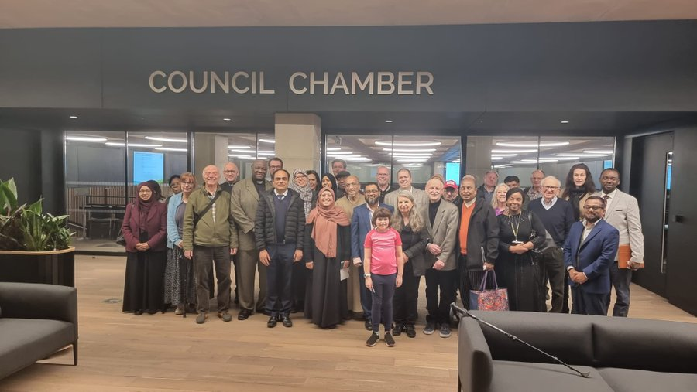
It is envisaged that all THIFF forum meetings going forward will be themed. This ensures that the work of the forum is of interest to residents of the borough and current events which impact upon the borough and those in it. Themes for the majority of forum meetings covered in this report were drawn from consultation with members of the public at the Tower Hamlets Festival of Communities in 2022 and it is hoped that the exercise will be repeated in June 2023.
Full details of future Forum meetings will be available on the events section of the THIFF website and can be found here: https://www.faithintowerhamlets.org/events/

Interfaith events
THIFF organises and runs two large interfaith events in the borough per year. One of these is during the Tower Hamlets Interfaith Week and the other is, typically, run early in the calendar year. In this reporting period an additional event was held in celebration of the work, and departure from the borough, of Reverend Preb. Alan Green.
The relevant events run by THIFF in the reporting period were:

Food, Faith and Fuel Event, May 26th 2022
Our annual themed event, Food, Fuel & Faith, took place in May 2022 at the Bernie Cameron Community Centre in Bow. The purpose of this event was to assemble local residents, faith organizations, council representatives, and other voluntary, community, and social enterprise (VCSE) groups with the objective of exploring the multifaceted ways in which faith and community leaders can provide support to their respective communities, as well as to identify and leverage the available local support mechanisms within the borough. Attendees were afforded the opportunity to network over food and drink, peruse informative information stalls, and actively engage in small group discussions.
We were pleased to host insightful presentations delivered by speakers from the Zacchaeus Project, The Felix Project, The Limehouse Project, and Tower Hamlets Council. All slides and images from the event can be found via the THIFF website event page: https://www.faithintowerhamlets.org/2022/05/26/food-fuel-faith-event-review/
This is an important, and growing issue, in the borough and one which THIFF will continue to be actively involved in working with partners on over the coming year.

Inter Faith Week 2022: Tower Hamlets Working in Partnership, 15th November 2022
The primary objective of the event was to emphasize the significance of partnership working within the borough. It was hosted by Reverend Preb. Alan Green, then the Chair of the Tower Hamlets Inter Faith Forum (THIFF). The event successfully gathered local residents, faith leaders, council representatives, and various voluntary, community, and social enterprise (VCSE) groups. Together we explored how faith and community leaders could initiate or enhance partnership working, thereby strengthening relationships and providing better support to the community. Attendees were able to network over food and drink, explore information stalls, and actively participate in a feedback activity with Tower Hamlets Council.
A pivotal component of the event was a panel discussion featuring high-profile panellists. These included The Rt Revd and Rt Hon Dame Sarah Mullally DBE, Bishop of London; Abbas Mirza, Community Engagement Lead at Barts Health NHS Trust; Sufia Alam, Head of Programmes and Maryam Centre at East London Mosque; Jon Williams, Engagement and Community Communications Manager at NHS North East London Integrated Care Board; and Afazul Hoque, Head of Corporate Strategy & Communities at London Borough of Tower Hamlets. The discussion was led and moderated by Reverend Preb. Alan Green.
The Bishop of London provided insights on the recently released report titled "On Faith, Place and Health." The report delved into the willingness of faith groups to collaborate with each other, local government, and the NHS to improve health outcomes. It highlighted the challenges and information gaps while also emphasizing the potential for faith leaders to contribute to addressing these issues. With this came recommendations for the NHS and local authorities to foster better integration and acknowledged the agency of faith leaders in driving change. The need for faith groups to be involved in co-design across all sectors, beyond health, was also strongly emphasised and well-received.
Abbas Mirza from Barts NHS Trust shared his insights on how the pandemic facilitated the collaboration of faith leaders with the health service. The Trust established a group that actively engaged with local faith groups during this period, ensuring a regular flow of information. The weekly meetings brought diverse groups together, leading to successful outcomes and even saving lives. The group is still active and continues to meet.
Jon Williams discussed the Tower Hamlets Together initiative, shedding light on the challenges posed by the cost of living crisis and underscoring the importance of allocating NHS resources appropriately to local communities. Tower Hamlets Together aims to understand the needs of the community and to influence and co-design services across the borough. They recognize the unique connections that faith leaders possess and acknowledge that transformation lies in collaborating with these leaders. This marks a significant shift how services have been planned and developed in the past. Now the involvement of communities is higher on the agenda.
Sufia Alam focused on the appetite for partnership working, emphasizing the need for faith leaders to have bold and meaningful conversations that yield tangible results. Being present at the table and negotiating for the necessary support plays a vital role in creating a substantial impact and effectively assisting local residents.
Afazul Hoque followed this by elaborating on the ongoing transformational efforts within the council, including acknowledging and celebrating the borough's diversity. It is imperative for the council to address key issues affecting the communities and ensure residents are informed about the available support. Faith groups have played a significant role in this regard, and the council's grant programmes offer opportunities for faith groups to extend their support further.
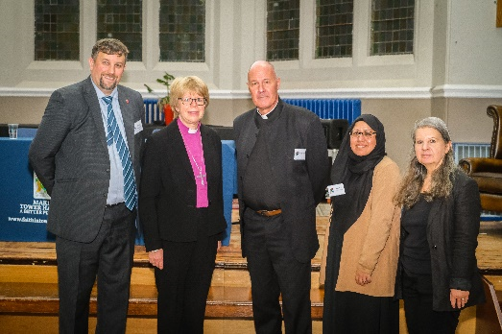
Following this, Frances Winter and Abidah Kamali from Tower Hamlets Council then shared insights on the Tower Hamlets Partnership Plan. They outlined how they support partners in developing a new vision for the borough by focusing on key priorities. The team actively conducts surveys, engages with residents, and collects input from various stakeholders to shape the future direction. Attendees were invited to provide their feedback during an interactive session.
Finally, in his framing comments to the event Rev. Preb. Alan Green, Chair of THIFF, spoke about the organisation’s important role as being a conduit for accurate information which can then be cascaded down throughout the various networks and contacts which THIFF is in touch with. This whole communication process depends on the principles of partnership working, creating trust and then, most importantly, actions happening on the ground and in our communities.
Looking forward to 2023, and heralding a time when he is no longer in London, Alan’s key message was to urge faith leaders and communities in the Borough not to be “coy” about the whole range of things that they are already doing in Tower Hamlets. He noted that “it can still be very hard to find out what is going on in faith communities and elsewhere.” The emphasis here was that faith leaders and the faith sector in general needs to tell their stories and be heard.

Farewell to Reverend Preb. Alan Green, 5th December 2022
THIFF’s longstanding Chair, Reverend Preb. Alan Green, stepped down from his role with THIFF at the end of 2022. After 24 years of working in Tower Hamlets, Alan has left Bethnal Green to take up a new, part time role near Brighton. As such an event was organized in December to commemorate Alan's accomplishments throughout his tenure of service to the communities in Tower Hamlets. Attendees from all walks of life across the borough shared remarkable recollections and reflections on the profound influence that Alan exerted during his extensive period in the borough.
Alan left those in attendance with a rallying cry to continue the work that he, and others, have undertaken in the borough over the last two decades:
“It has been a pleasure and a privilege to be a resident and a parish priest here. It is important to remember that there is a rich history in Tower Hamlets about standing together, but it is vital not to assume this just happens. It takes hard work, commitment, and understanding, and only happens if there is constant work in building good relationships. It requires a commitment that I know will carry on in Tower Hamlets”
—Reverend Preb. Alan Green, December 2022
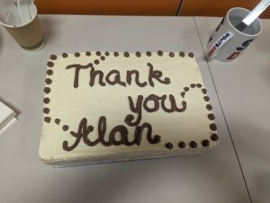
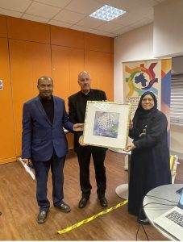
In addition to these Inter Faith Week events, THIFF also hosted, or played a key role, in the following events during the reporting period:
Brick Lane Mosque Visit by the King and Queen Consort | 08/02/2023
Holocaust Memorial Day 2023 | 27/01/2023
Barts NHS Faith Leader Meetings | Monthly throughout the reporting period
Tower Hamlets Public Health Winter Engagement | 28/07/2022 to 26/01/2023
Faith Health Action Partnership end of project event | 02/03/2023

Collaboration and partnership working
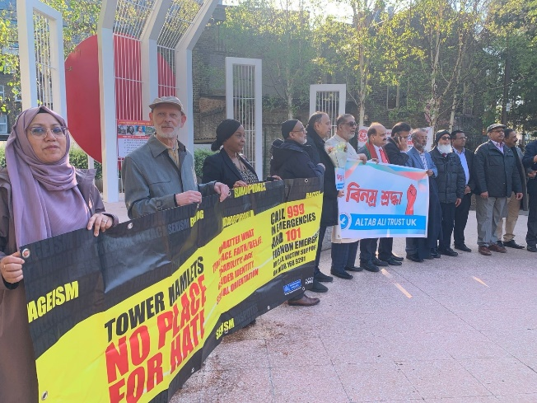
The work undertaken by THIFF is greatly strengthened by other individuals, organisations and partners with which it works, collaborates and engages with. This collaboration is mutually beneficial as THIFF aims to bring value and profile to those with whom it works.
Below is a list of many of the organisations with which THIFF has worked with, formally and informally, in the reporting period of this Annual Report.

Barts Health NHS Trust
Bernie Cameron Community Centre
Bethnal Green Foodbank
Blue Gate Fields Primary School
Bow Foodbank
Breathing Space London
CAC Narrow Gate
Canary Wharf Chaplaincy
Canary Wharf Group PLC
Christ Apostolic Church
Coventry University
Cycle Sisters
Debt Free London
Disabled People’s Network
Dorset Community Association
E1 Networking
East London Mosque
East London NHS Foundation Trust
Elop- LGBT Consortium
FaithAction
Felix Project
Globe Community Project
Healthwatch Tower Hamlets
Kobi Nazrul Centre
Lifeline Projects
Limehouse Project
London Borough of Tower Hamlets
London Boroughs Faith Network
Mayflower School
Metropolitan Community Church
Metropolitan Police
Mowlem School
Mulberry School
Neighbours in Poplar
Newark Youth
Newham African and Caribbean Resource Centre
NHS North East London
No Place for Hate
Northern Trust
Older People’s Reference Group
One Tower Hamlets
Pilgrim's Tabernacle
Poplar Harca
Positive East
Praxis
Queen Mary University
RCCG Jubilee Hall
Real Tower Hamlets
SACRE
Shoreditch Tabernacle
St Hilda’s Community Centre
St Margaret’s House
St Pauls School
St Pauls Shadwell
St Peter’s Bethnal Green
Strengthening Faith Institutions
The Feast
Thomas Buxton School
Tower Hamlets Community Safety Partnership
Tower Hamlets Connection Network
Tower Hamlets CVS
Tower Hamlets Ethnic Minority Network
Tower Hamlets GP Care Group
Tower Hamlets Homes
Tower Hamlets LGBT Community Forum
Tower Hamlets Talking Therapies
Tower Hamlets Tension Monitoring Group
Tower Hamlets Women’s Group
Tower Hamlets Youth Council
Trapped in Zone One
Wapping Noorani Masjid
Zacchaeus Project

Project Work

Faith Health Action Partnership (FHAP)
The FHAP project was funded by Tower Hamlets Public Health and run by FaithAction in partnership with East London Mosque and supported by THIFF. The project worked to support 8 local faith settings and faith based organisations to deliver 10 different health focused projects to the local communities. This work built on the work of the Faith COVID Assistance Partnership (FCAP), also delivered with the support of THIFF, which provided support and free COVID-19 infection prevention supplies to many places of worship in the borough throughout the pandemic.
The projects were run by local faith-based groups, and in local faith settings, and offered a wide range of health-based interventions, including activities for young people, healthy eating guidance, fitness sessions and blood pressure checks. These projects were co-developed with the local faith providers to ensure that they address real, localised community need in Tower Hamlets.
The 8 faith-based groups funded to run projects in the borough through FHAP are; Cycle Sisters, Christ Apostolic Church, Shahporan Masjid & Islamic Centre Trust, Globe Community Project, Dorset Community Association, Newark Youth London, East London Mosque and Wapping Noorani Masjid & Cultural Centre.
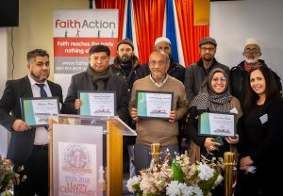
These projects directly engaged at least 245 participants and indirectly reached at least 651, with this latter figure likely representing a considerable under-estimate. There has been a wide diversity of different projects reaching an equally diverse number of cohorts and this has enabled the momentum built by the FCAP to be maintained.
Participants in the projects have seen tangible physical health benefits from designed in activities such as undertaking exercise and the increased awareness of blood pressure issues, but also saw equally important outcomes which weren’t overtly targeted at participants. These include participant led discussions around both mental health and the menopause and these, in turn, allow the projects to signpost participants towards formal interventions.

Churches Health Action Partnership (CHAP)
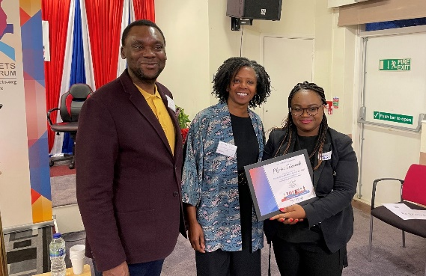
In addition to the FHAP project, THIFF supported another project led by FaithAction and funded by Public Health – the Churches Health Action Partnership (CHAP). CHAP worked with four churches attended by predominately African worshippers, and sought to support people through the winter pressures, and to run health and wellbeing projects similar to those in the FHAP work. The project ran for three months, and in that time had a great impact on the health and wellbeing of attendees, indirectly reaching 257 people.

The Cornerstone Project
The Cornerstone Project is a partnership between Tower Hamlets Council for Voluntary Service (THCVS) and seven service user-led community groups and organisations representing the different equalities strands. Known as the Tower Hamlets Equalities Partnership, this is a two- year project, funded by The National Lottery, that aims to influence more inclusive decision-making processes across public sector agencies in the Borough. Through its work, the Partnership seeks to ensure that improved planning and decision-making better reflects the experiences and needs of disadvantaged and marginalised communities.
As well as creating the Partnership, work includes co-producing with our communities a resource of good practice guidance and materials for delivering more inclusive Public Sector decision-making processes, including Equality Impact Assessments (EqIAs) and testing these, as well as raising awareness and understanding of the different equalities issues and experiences across our communities through practical, lived, understanding of intersectionality and how this applies in Tower Hamlets. In the year 2022-23 THIFF helped shape a successful Lottery bid and now contributes to the initial mobilisation work. Partners are: THCVS; Account 3; elop; Limehouse Project; Real DPO; THIFF; Older People’s Reference Group (Age-UK), and Women’s Inclusive Team.

Other outcomes
THIFF works to research and collect information of all faith and non-faith celebrations to produce an annual inter-faith calendar. 1,000 calendars were printed and distributed in the reporting period covered by this report. The calendars were distributed to at least:
- 60 schools primary secondary and special needs schools
- 30 community organisations
- 4 businesses
- 130 faith institutions and organisations
- 5 Idea store libraries
- 3 council buildings
The 2023 Faith Calendar is available online here: https://www.faithintowerhamlets.org/resources/#faith-calendar
Please contact THIFF via email if you would like to be sent a physical copy.
THIFF is also active on the main social media platforms of Twitter, Facebook and Instagram. At the time of writing THIFF has 1,554 followers on Twitter and is an increase on the previous year. THIFF primarily use this platform to promote meetings and events of THIFF and other community partners/projects. It also uses Twitter for sharing news and consultations from the London Borough of Tower Hamlets, as well as promoting funding opportunities, and funding available from other organisations.
The THIFF mailing list currently has 375 individuals and/or organisations signed up to it. At least two updates are sent each month with update on events and work of THIFF, as well as relevant community updates, including London Borough of Tower Hamlets messaging.
In the reporting period, 22 THIFF Newsletters & updates were sent out to the mailing list and other faith bodies and groups in the borough. This has maintained the momentum that THIFF built when taking on a central role in the faith, community and voluntary sector in the borough as a trusted and reliable source of advice and guidance during the COVID-19 pandemic.

Looking Forward
THIFF forum meetings will continue to run throughout 2023 and 2024 and will be based on areas of thematic interest which have been chosen in consultation with local people and partners. Additionally, THIFF will host an extraordinary AGM in the Autumn of 2023 to elect (or re-elect) Steering Group members and the Chair. Attendance at these events is open to all and information about upcoming Forum meetings, including dates, times and venues can be found here: https://www.faithintowerhamlets.org/info/meetings/
The Forum and representatives will attend the Tower Hamlets Festival of Communities on Saturday the 10th June and will be consulting with those in attendance about local priorities and desired areas of focus for the work of the Forum over the coming year. We will also hold a major event to mark Interfaith Week in Tower Hamlets. This will be held in November 2023 and more details will be available by the end of Summer 2023.
Finally, THIFF will continue to be a leading presence in the borough and a key partner for faith and non-faith agencies. Through its own work and association with the TH Equalities Hub, it will continue to develop partnerships and engage in consultations across the borough. The experiences of working collaboratively with partners, old and new, across the borough has developed and strengthened bonds and shared interests, and THIFF will work over the coming year to consolidate these.

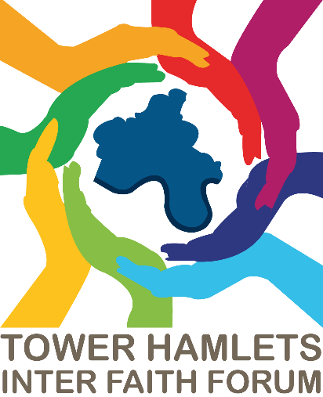
www.faithintowerhamlets.org
twitter.com/thinterfaith instagram.com/th_iff
facebook.com/THInterFaithForum

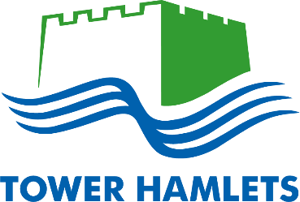
  - Supported by

