THIFF Forum Meeting Summary: Small Grants Fund & State of Sector
Monday 16 October 2023, 6-8pm at London Muslim Centre, Whitechapel

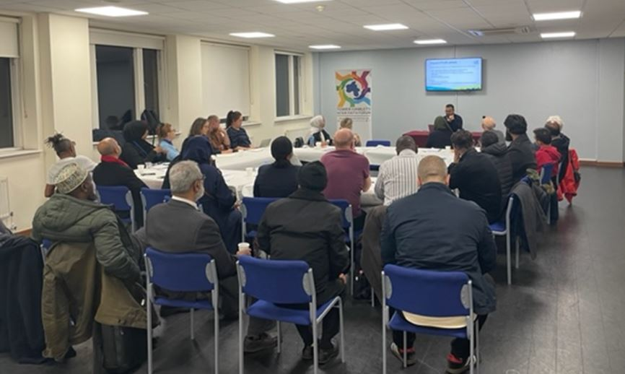
Welcome – from Sufia Alam
Khalid Sali, Tower Hamlets Council, VCS Development Officer
Highlighted the impact of the work of faith groups in the borough.
- Funding opportunities for faith groups coming up:
- Small grants – capacity building, community events, community chest (six times a year). Timelines: Round 1 – 11th Dec 2023 to 2nd Feb 2024.
Small grants - type of projects
Capacity Building (Learning and development which improves your management committee, staff and volunteer skills, consultancy to get specialist advice/guidance to your organisation, marketing, communications and bid writing support, research and evaluation)
Community Events (Room or venue hire, transport hire, refreshments, insurance costs, marketing and equipment, costs of workshops or facilitators)
Community Chest (Room or venue hire, transport hire, refreshments, Insurance costs, marketing and equipment, workshops or facilitators)

What makes good application?
- Value for money – volunteers, additional funding
- Evidence of need
- Social value
- Organised well-researched project
- Clearly defined outcomes/outputs
- Demonstrating track record
- Well considered budget

Previously funded projects:
- Sports projects
- Community litter picking
- Safer Parks
- Senior citizens health projects
- Education and training
- Food banks
- Luncheon club
Faith groups are welcome to apply.
Things to consider when applying!
- Can you add money from another source? This may help application.
- Evidence of need – have you spoken to your community
- Social value – using local suppliers e.g. local caterers for an event will help with your funding bid.
- Well researched - give evidence of e.g. contacting organisations for what they will charge so that you can budget.
- Clearly defined outcomes – How many people will your project reach? , what difference will project make – how will you stand out of the crowd
- Well considered budget – how did you come to the figures? Do you have quotes. Is it realistic
Take a look at the slides for some examples of other funding.
Questions
Q – Only organisations that have been previously funded by the council are eligible to apply for emergency funding. This really creates barriers, can it be changed?
A – The council are reviewing this. Hopefully the new eligibility criteria will be published by December 2023.
Q – Many funds involve co production. Can THIFF be funded collectively to distribute grants to smaller organisations?
A – This question would need further consultation with colleagues, however THIFF could apply as a consortium.
Q – Can we use the money to employ sessional workers? This is more expensive than a long term worker.
A – Most of the activities that will be funded are one off, however, the council can fund workshops and facilitators, so you can pay them from the fund.
Comment – Tower Hamlets CVS does capacity building for free – can support with bids, so this support already exists.

Sam Crosby, Development Officer, Tower Hamlets CVS
State of the Sector Report
- Key challenges – short term funding, recruitment, retaining staff.
- Financial issues were the focus, many charities reported that their organisation was secure only for two years or less – and 11% were close to closure
- Capacity is an issue for many when doing fundraising. Not many can afford to hire a dedicated fund raiser. Also impacts on awareness of other forums, training and funding.
- What support would you like from CVS?
- Connections with funders, however for smaller orgs the capacity building is more needed.
- CVS offering support for transition – training in diversifying income stream and how to demonstrate impact – coming up (see website)
Comment from attendee – Help with local authority funding- does that reflect austerity so that help requested from orgs is not available?
Benedicta Dikeocha, Hate Crime Projects Officer, Tower Hamlets Council
- Works for Tower Hamlets Council VAWG and Hate Crime Team as hate crime projects officer. Role is to coordinate the partnerships that address hate crime and VAWG.
- Coordinates monthly incident panel for victims of hate crime. Looks at how they can resolve situation.
- Also organised quarterly No Place for Hate forum – a number of orgs – share best practice and have an annual delivery plan where different orgs can come together and share aims to address hate crime.
- Mark key dates in the hate crime calendar, eg Holocaust memorial, LGBT History Month, etc ….October – National Hate Crime Awareness Week….also No Place for Hate Champions Training – recruit residents, professionals so that people can become ambassadors in their own community, school or faith setting.
Atikur Rahman, Trustee, Wapping Noorani Masjid & Cultural Centre & Wapping Bangladesh Association, received funding from Mayors Community Grant Programme.
- Organisation gradually grew, important to be hopeful about gaining funding. Have received various funds in the past, inc Henry Smith funding.
- Always be mindful of capacity – and approach other organisations to work in partnership.
- Need strong management team - sometimes it is hard to get the right people.
- Engage people that have been with the organisation for a long time.
- Match funding has advantages.
- If no funding available, try to continue running project with existing services and volunteers. Work from the ground level and don’t give up hope.

Information Sharing
Comment from Leon Silver, Steering Group Member – We are living in terrible times and feel grief for all of the innocent people in both Israel and Gaza. We are all human beings and horrified – let it not tear our communities apart.
German Lutheran Church, in Alie Street, holds talks once a month, one tomorrow (17th) at 7pm on Royal London Hospital. The talks are monthly, both in person and on-line ( tickets at the door or via Eventbrite) and the talk on 15th November will be on Clement Attlee, youth worker in Stepney, mayor of Stepney, MP for Limehouse and Prime Minister of the UK. All events can be found here.
East London Mosque Community Health Fair, 21st October - lots of health partners are involved, free food, and upcoming CPR training.

