THIFF Forum Meeting Summary: London Fire Brigade and LBTH Fostering Team
Tuesday 16 January 2024, 6-8pm at Account 3, Bethnal Green

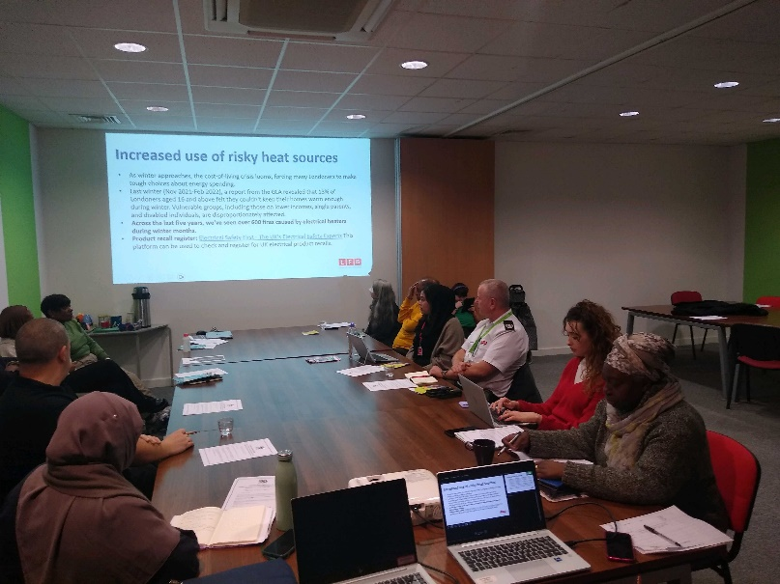
Welcome – from Sufia Alam
Paula Lyttle and Faisa Yusuf from LB Tower Hamlets Fostering Recruitment & Assessment Team,
Paula and Faisa kindly presented on the issue of
- Foster carers and vulnerable children
- Foster carers for fostering family.
- Wide range of ages
- Range of reasons for children being taken into care
- Importance of family environment
- Recruitment challenges – lack of awareness – limited engagement opportunities
- Spreading awareness about fostering
- Highlighting importance of fostering- networking opportunities
- Social media platforms
- 0-18
- 21 min age
- Diverse families
- Short term and long-term fostering
- Foster incentives – monetary incentives – continuous training and support – care worker support – entering a community – wide range of training opportunities – supports for specialist needs -
- Honours and rewards
- Community conference focused on fostering – tackling the misconceptions.
- Social media content being sent over
- • Foster carers decreased and needs are increasing.
Sam Crosby, Development Officer, Tower Hamlets CVS -see slides
State of the Sector Report
- Key challenges – short term funding, recruitment, retaining staff.
- Financial issues were the focus, many charities reported that their organisation was secure only for two years or less – and 11% were close to closure
- Capacity is an issue for many when doing fundraising. Not many can afford to hire a dedicated fund raiser. Also impacts on awareness of other forums, training and funding.
- What support would you like from CVS?
- Connections with funders, however for smaller orgs the capacity building is more needed.
- CVS offering support for transition – training in diversifying income stream and how to demonstrate impact – coming up (see website)
Comment from attendee – Help with local authority funding- does that reflect austerity so that help requested from orgs is not available?
Benedicta Dikeocha, Hate Crime Projects Officer, Tower Hamlets Council
- Works for Tower Hamlets Council VAWG and Hate Crime Team as hate crime projects officer. Role is to coordinate the partnerships that address hate crime and VAWG.
- Coordinates monthly incident panel for victims of hate crime. Looks at how they can resolve situation.
- Also organised quarterly No Place for Hate forum – a number of orgs – share best practice and have an annual delivery plan where different orgs can come together and share aims to address hate crime.
- Mark key dates in the hate crime calendar, eg Holocaust memorial, LGBT History Month, etc ….October – National Hate Crime Awareness Week….also No Place for Hate Champions Training – recruit residents, professionals so that people can become ambassadors in their own community, school or faith setting.
Atikur Rahman, Trustee, Wapping Noorani Masjid & Cultural Centre & Wapping Bangladesh Association, received funding from Mayors Community Grant Programme.
- Organisation gradually grew, important to be hopeful about gaining funding. Have received various funds in the past, inc Henry Smith funding.
- Always be mindful of capacity – and approach other organisations to work in partnership.
- Need strong management team - sometimes it is hard to get the right people.
- Engage people that have been with the organisation for a long time.
- Match funding has advantages.
- If no funding available, try to continue running project with existing services and volunteers. Work from the ground level and don’t give up hope.
Information Sharing
Comment from Leon Silver, Steering Group Member – We are living in terrible times and feel grief for all of the innocent people in both Israel and Gaza. We are all human beings and horrified – let it not tear our communities apart.
German Lutheran Church, in Alie Street, holds talks once a month, one tomorrow (17th) at 7pm on Royal London Hospital. Also online. 15th November: talk on Clement Attlee? MP for Limehouse. All events can be found here.
East London Mosque Community Health Fair, 21st October - lots of health partners are involved, free food, and upcoming CPR training.

