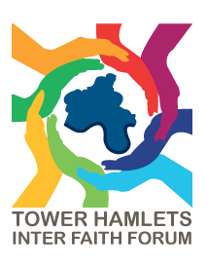
THIFF FORUM MEETING: Learning English, Building Confidence, and Strengthening Community
Location: Watney Market Idea Store
Date: Monday 14 July 2025
Time: 6-8pm

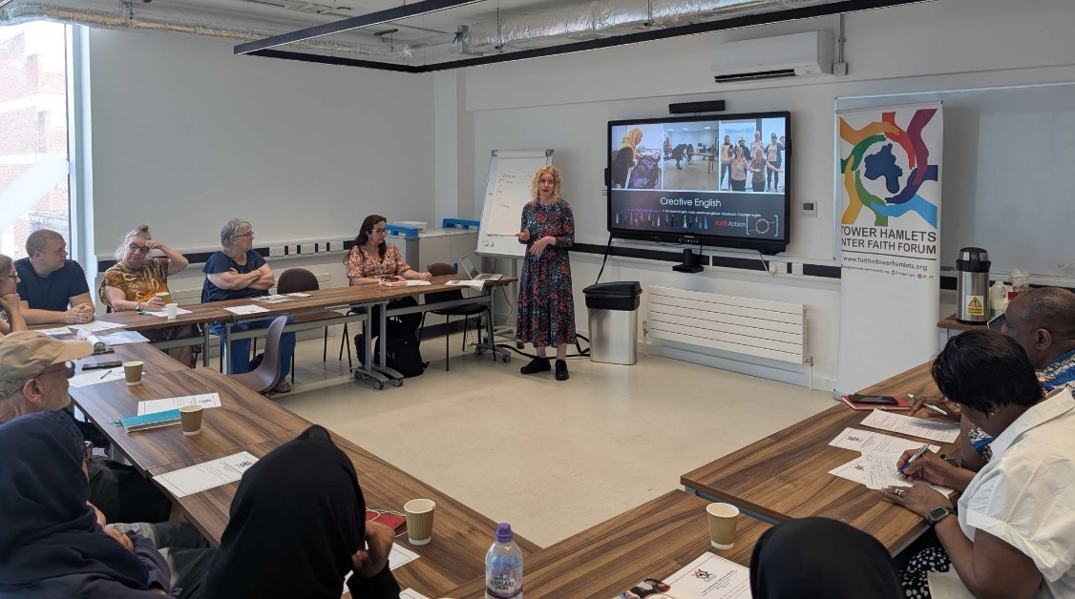

In July, we hosted an evening focused on language, confidence, and belonging. The meeting brought together faith leaders, educators, and community members from across Tower Hamlets to explore how we can better support people learning English—especially those facing barriers to accessing services.
The evening’s keynote speaker was Dr. Anne Smith, who introduced the Creative English programme. It’s a fun, drama-based way to learn English through storytelling, role-play, and everyday situations like visiting the doctor or shopping. Delivered in faith and community settings, it’s already helped over 25,000 people across the UK.
“It’s not about tests or textbooks—it’s about confidence,” said Dr. Smith. “When people laugh and feel relaxed, they learn faster and make friends along the way.”
Creative English
Creative English is an innovative, community-based English language programme designed to help adults with low or no English build confidence in spoken English for everyday life. It is particularly aimed at migrants, refugees, asylum seekers, and socially isolated adults, especially those who do not thrive in traditional classroom learning.
Creative English focuses on building confidence and practical communication, rather than formal grammar or exams. The aim is to help people function independently in daily situations such as:
- Talking to doctors, teachers, and landlords
- Shopping and using local services
- Supporting children at school
- Engaging with neighbours and the wider community
How the Programme Works
- Uses drama, role-play, games, storytelling, and humour
- Participants “learn by doing” in a safe, supportive, and fun environment
- Delivered by trained community volunteers
- No written work or prior English knowledge required
- Sessions typically run weekly, either as:

- A full programme (up to 38 sessions), or
- Shorter courses (around 10 weeks), adapted to local needs
Key Features
- Participant-led learning based on real-life situations
- Encourages peer support and friendship
- Builds both language skills and social confidence
- Especially suitable for people with low literacy, limited education, or high anxiety around formal learning
Types of Creative English Programmes
Creative English has expanded into a suite of themed programmes, including:
- Original Creative English (everyday English)
- Creative English for Health (accessing NHS and health services)
- Creative English for Parent and Child (family learning)
Community members shared their own experiences and teaching strategies:
“I use play therapy and role-play with my adult learners. In just four weeks, they went from saying ‘I don’t know’ to writing full sentences. It’s amazing to see their confidence grow.”
Another attendee added:
“We pair stronger learners with those who are just starting out. It’s like a school setting—everyone learns from each other.”
There was also discussion about the limits of language apps and translation devices. While technology can help, many agreed that face-to-face learning is more effective—especially for older adults or those feeling isolated.
“Devices can’t replace human connection,” said one participant. “People want to get out, meet others, and feel part of something.”
The forum also featured updates from local groups:
- Praxis shared their new Migrant’s Guide, created by service users to help others navigate life in Tower Hamlets.
- St Mary’s Church is running monthly community litter-picking events to encourage conversation and connection.
- The Roots of Wellness project is supporting older women with friendship, wellbeing, and English conversation.
The evening ended with a call to keep networking, share resources, and support each other in helping residents overcome language barriers and feel a stronger sense of belonging.
“Let’s link up, learn from each other, and make sure no one is left behind,” - Rev James Olanipekun, Interim Chair, THIFF
Big thanks to everyone who came, shared, and contributed—and especially to Dr. Anne Smith of FaithAction.
You can find more information on running Creative English here.

