
THIFF Forum Meeting Minutes: Food Insecurity
Monday 12th May 2025, Good Shepherd Mission, Bethnal Green

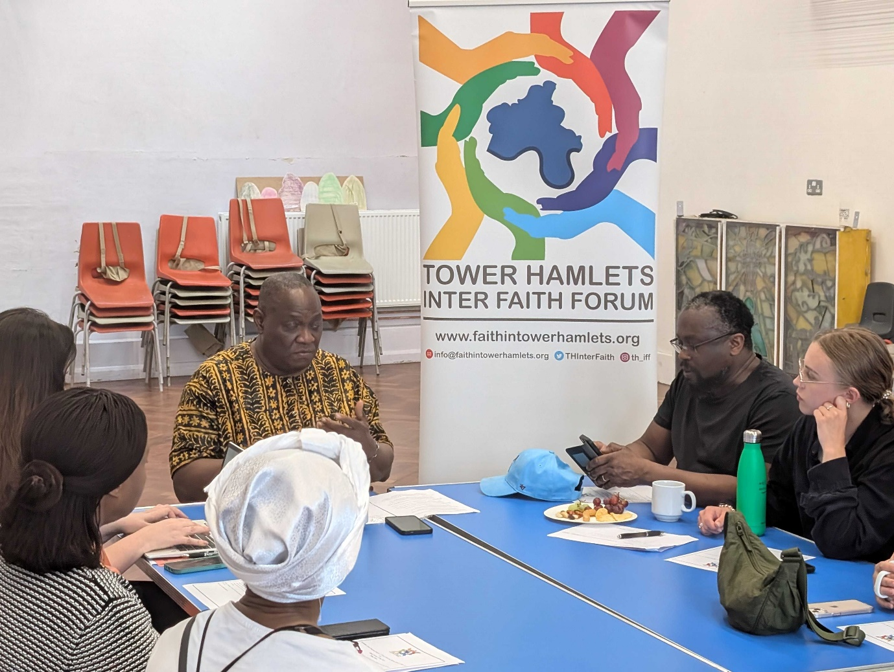

Introduction: Rev James Olanipekun, THIFF Interim Chair
Rev James emphasised the forum's influence: “This forum has a voice — and it can be a loud voice” and encouraged more engagement with authorities to amplify community concerns through trusted faith-based networks. He then introduced the main topic of the evening – food insecurity:

  - Importance of addressing poverty holistically — not just food banks but systemic solutions.
  - Concern over under-publicised support options.
  - Clear links between health implications and long-term conditions tied to food poverty.
  - Stigma, shame, and social impacts for those using food services.

Speaker: Ryan Lynch – Good Shepherd Mission
- Over 45 years in operation (building from 1851).
- Offers extensive community services:
  - Foodbank, homelessness outreach, youth work, women’s groups, mother & toddler groups.
  - Monthly Saturday family activities and continuous outreach.
- 50 volunteers – who are essential to operations. Funding primarily from church congregation (minimal council funding).
- All guests receive free food — the people that come along are not seen as ‘clients’ but as community members.
- Drug recovery support – including rehab referrals and a football team led by an ex-addict.

Discussion Section: Challenges and Observations
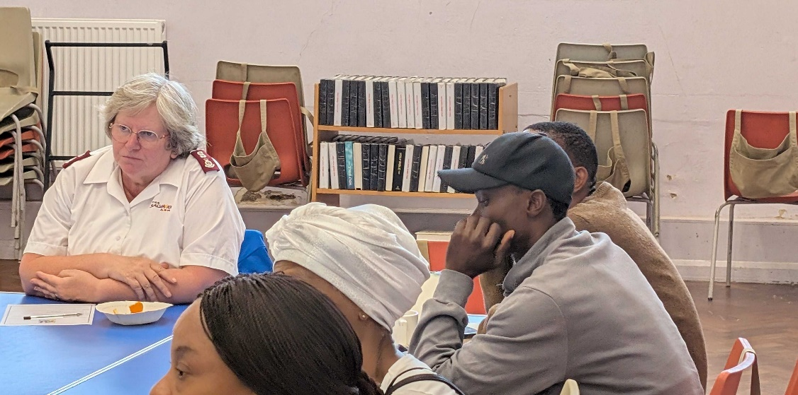
Food Poverty & Causes
- Bow Foodbank: Multifaith origins, their service peaked during the pandemic , providing food to 1,000 families a week); numbers have fallen now to about 500 a week but this figure is rising.
- Causes of food poverty are complex and varied:
  - Housing quality and rising rents.
  - 2-child benefit cap, language barriers, limited knowledge of entitlements.
- Faith groups and mosques also offer food services — however, better mapping of these services is needed.

Language Barriers & ESOL
- High demand for English classes – insufficient provision of pre-ESOL (basic literacy) support.
- Isolation due to language leads to reliance on interpreters.
- Initiatives like Chatty Café help with informal learning.
- Churches and volunteer groups offer ESOL and basic support.
- Suggestion to better coordinate capital and spaces in faith settings for teaching.

Housing and Social Challenges
- Immigration and housing rules affecting stability.
- Family breakdowns are often a challenge to be navigated, especially linked to visa status and domestic abuse.
Structural issues keep people in poverty.
Those in Salvation Army hostels can’t work without losing benefits — the system creates dependency.
Unemployment & Health:
  - Underlying health conditions impact employment opportunities.
  - Issues like addiction, gambling, and family breakdown exacerbate poverty.

Access to Cooking & Food Facilities
- Many lack access to kitchens or refrigeration.
- Fast food often cheaper than home cooking due to energy costs.
- Initiatives:
  - Cadent partnership – distributed slow cookers.
  - Community kitchens and food education are crucial.
- Identified gaps:
  - Fuel poverty, basic cooking skills, food storage.

Support & Coordination
Mapping and Referral Systems
- Current mapping systems inadequate – they don’t cover baby banks, or place for school clothing, etc.
- Proposal: Use Plinth platform:
  - Community-owned CRM to track visits and outcomes.
  - Funded partly by Bow Foodbank.
  - Allows individual stakeholders to keep their data (such as opening times etc) updated, allows better referral network.
Social Prescribing & Outreach
- Suggest inviting social prescribers to forums.
- Joy App replacing THCAN — useful for referrals.
- Outreach ideas:
  - Supermarkets as info hubs.
  - Faith and community events to build trust.
  - More systematic and unified flyer distribution.

Engagement with Local Authority
- Positive response from Mayor’s team after recent campaign on food hub funding.
- Urged creation of a cohesive representative body (not political, but advocacy-focused).
- Emphasised need for:
  - Data and case studies to demonstrate impact.
  - Monetary value of volunteer hours (estimated £2M+).
  - Authentic engagement — “council officers need to meet residents face to face.”

Local Initiatives mentioned during discussion
- Alexandra Rose Vouchers (Rose Vouchers - Alexandra Rose)
  - Aimed at promoting healthy eating.
  - Referrals via healthcare professionals or social prescribers.
  - Estimated value: £40/month for fruit & veg.
- Family Hubs (Tower Hamlets | Family Hubs)
  - Provide essentials (e.g., nappies) along with food.
  - Need better inclusion in food support mapping.
Next meeting will look at how a potential lack of suitable English language learning opportunities impact upon a person’s ability to find support

