

Tower Hamlets Inter Faith Forum
A Place to Call Home, 18th November 2025
St Margaret’s House, Old Ford Road, Bethnal Green

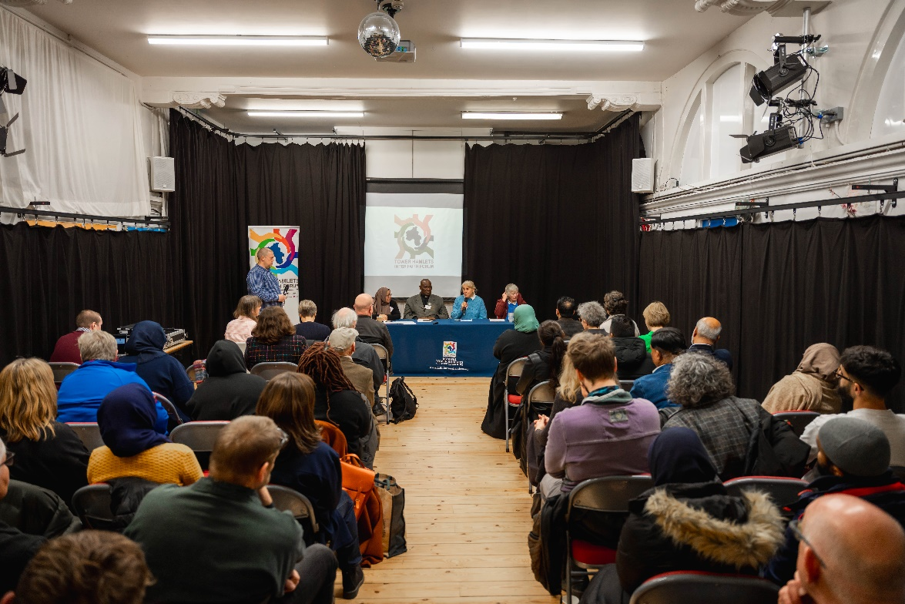

Tower Hamlets Inter Faith Forum celebrated Inter Faith Week 2025 by holding an event focused on housing in security in Tower Hamlets.

Over 60 attendees joined us to come together and explore the current housing landscape in the borough and hear how faith groups are supported people in need.

The event brought together faith leaders, council representatives, health experts, researchers, and residents to discuss the deepening housing crisis in Tower Hamlets and the role faith communities play in responding to it. Local organisations connected with attendees as stallholders – we were very please to be joined by Bow Foodbank, Sister Circle, FaithAction, Tower Hamlets VAWG team and Thai Boxers Academy.
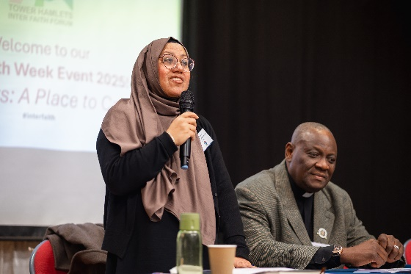
The event opened with hosts, THIFF Co-Chairs Sufia Alam, Maryan Centre at East London Mosque and Rev James Olanipekun, Christ Apostolic Church, acknowledging that housing insecurity affects every faith, every neighbourhood, every demographic in the borough. The wider goal is to strengthen cross-faith collaboration, raise awareness of urgent housing issues, and develop practical pathways for joint action.

Councillor Musthak Ahmed, Cabinet Member for Jobs, Enterprise, Skills & Growth, London Borough of Tower Hamlets

Councillor Ahmed’s speech emphasised partnership and collaboration in the borough.

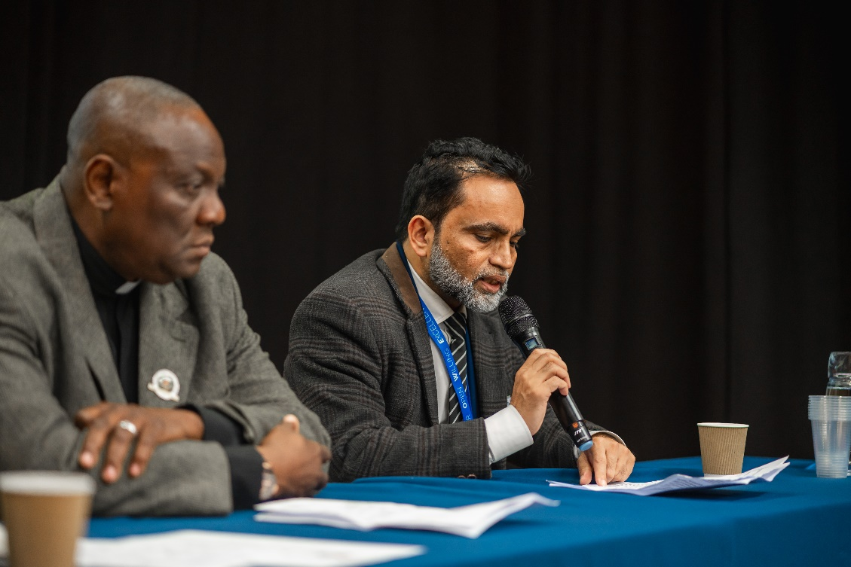

“When different faiths come together, they amplify their impact. They share resources, knowledge, and networks. And that creates stronger safety nets for our most vulnerable residents. Interfaith collaboration is not just powerful [but] essential. I want to encourage all of you…. faith leaders, organisations and partners, to keep building these bridges. Let's flourish. Let's continue to work together and with the Council.”

He highlighted ways faith groups can practically support local housing resilience—such as joint initiatives, volunteering schemes, and awareness campaigns and he believes that “together we can ensure that every person in Tower Hamlets has not just a roof over their head, but a place they truly call home”

The Venerable Archdeacon of Hackney, Peter Farley-Moore

Archdeacon Farley-Moore gave a spiritual exploration of what “home” means: “The ache for home lives in all of us, that safe place where we can go as we are and not be questioned.”

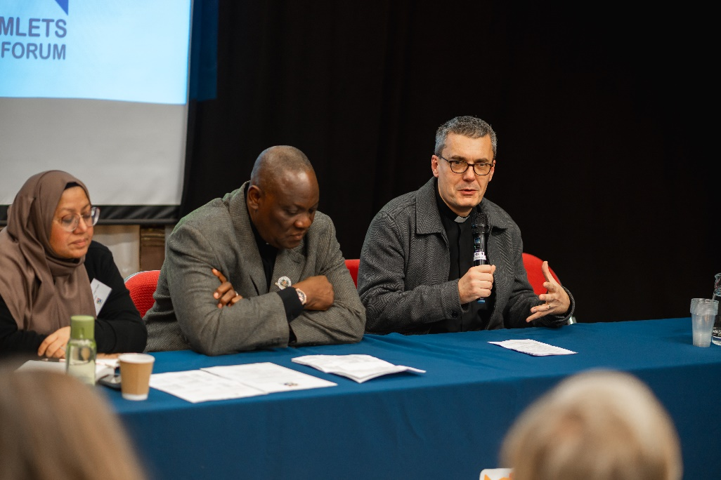

He described home as a sacred space, a foundation for ritual, tradition, welcome, and learning. Drawing on imagery across faiths, he noted: “Heaven is often the word used to describe that sense of eternal home and safety. But unfortunately, ‘hellish’ is the more common adjective used to describe the housing crisis in London.”

The Archdeacon referred to the 300,000 people in England living in unsafe or temporary accommodation, comparing it to the population of Tower Hamlets:
“That statistic is shocking… that number of people living without the safety many of us take for granted.”
“A home is a place for family life to be nurtured; it represents our inherited traditions and that sense of wisdom that's passed down from one generation to another. In many faith traditions, the home will be a place for welcome and hospitality, of caring for others beyond our immediate kind of nuclear family. The Arabic word for home is maskan, and it's a word that's got its roots in peace and rest and tranquillity - I think that's a beautiful description of what a home is.”

He closed with a powerful hope:
“My prayer is that the hellish experience around housing will be transformed into a more heavenly one.”
Karen Swift, Director of Housing Strategy for Tower Hamlets Council

Karen Swift, Director of Housing Strategy for Tower Hamlets Council, provided a data-driven breakdown of the borough’s housing conditions:
- 38% of housing private rented – “our biggest tenure… one of the highest in London.”
- 36% is social rented – (housing association and council homes)
- 26% are owner-occupied – “the lowest in the UK.”
- 7.8% of all Airbnb’s in London are in Tower Hamlets – second highest borough.

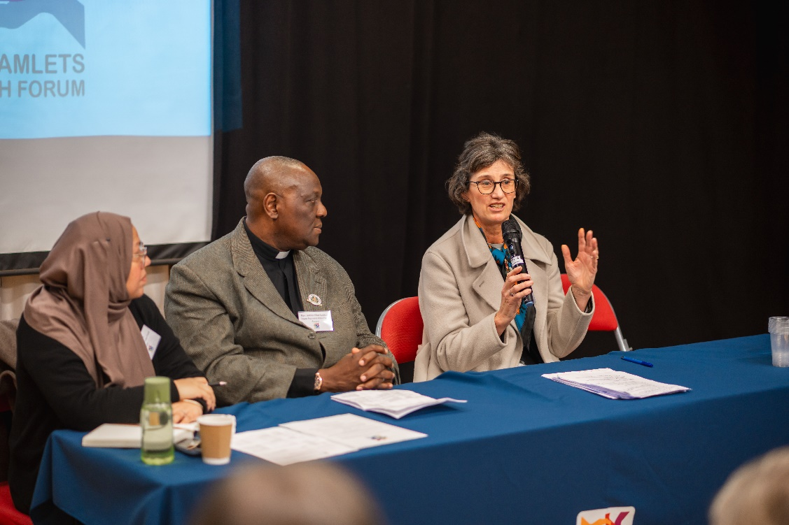

Karen spoke of temporary housing in the borough – there are 3,300 homeless households, predominately families and about 60% of them are housed outside the borough because the council cannot find housing for them within Tower Hamlets.
She explained that the housing register holds 29,000 households, of which 45% are overcrowded. The figures include families or individuals “sleeping on a friend’s couch… needing ground-floor housing… or simply having no home at all.”

There is an affordability crisis in the borough; Karen stated that “a single person would have to earn £50,000 to rent a one-bedroom flat in Tower Hamlets” but she also highlighted positive progress that 1,500 homes have been built in the time period of 2022–2025, comprised of 288 new council homes, 200 ex-Right-to-Buy homes being reacquired, with £140 million invested in improving council housing.

Karen spoke of the Renter Reform Act, emphasising its significance: “It will be the biggest reform in the private rented sector in 40 years”, including abolishing no-fault evictions, ending bidding wars, a national landlord database and rent increases can only happen only once a year. Abolishing ‘no fault evictions’ is a positive step in reducing a main driver of homelessness.
“Letting agents will be in the firing line if they're not renting it the rent that's advertised. All landlords will have to be registered on a national database. They'll have to upload gas safety records every year, tenancy agreements, and if they don't, they'll be fined by the local authority £7,000”

Finally, Karen highlighted the council’s newly launched consultation on housing, of which THIFF is invited to their consultancy event, taking place in early December (details on THIFF website)

Emily Humphreys, Public Health Consultant, Tower Hamlets Health Determinants Research Collaboration

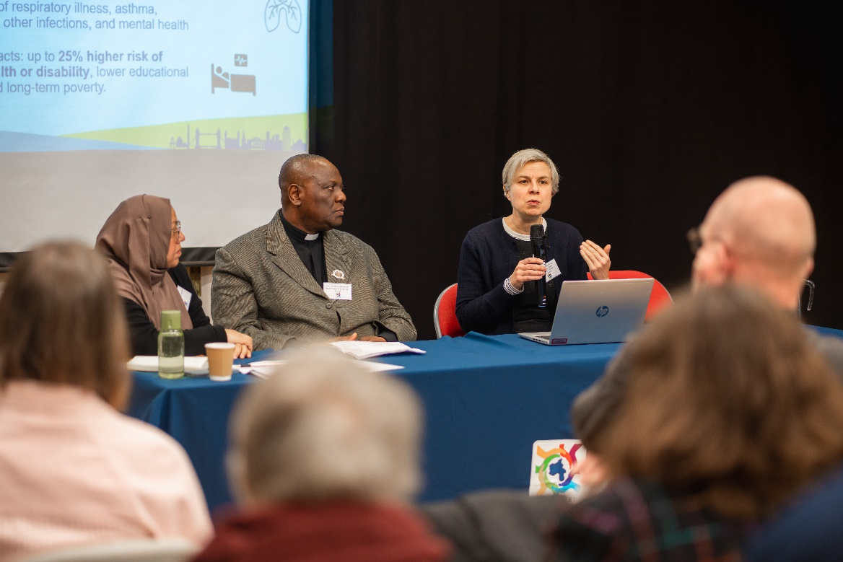

Emily leads on Health Determinants Research Collaboration, which exists to support the council to use evidence better in everything it does to understand the problems that are facing residents and what research tells us about how to resolve those problems - housing is the first area that the team are working on. Emily provided evidence linking housing conditions to health outcomes, noting that “The annual NHS cost of poor housing is £1.4 billion.”

Emily explained that housing affects health in multiple ways: poor affordability, insecurity, and homelessness can create social and mental health problems, while poor conditions like damp, overcrowding, or extreme temperatures can harm physical and mental health. Additionally, the wider neighbourhood—access to safe play areas, for example—also influences social, mental, and physical wellbeing, especially for children.

“Children who experience multiple moves are at a really high risk of depression as adults.”

“Excess winter deaths begin at temperatures like we have this week—it doesn’t have to be below freezing.”

“If you can't get out to a good play area for your kids, then they're not going to get as much exercise, they're not going to socialise as much, and that's going to have both short-term impacts on their mental health as well as longer-term impact on their physical health”

The research aims to improve housing-related outcomes by identifying the most impactful areas to study, working closely with residents, council staff, researchers, and voluntary organisations. Three projects are underway: 1. examining the health impacts of severe overcrowding, 2. collaborating with residents to co-produce solutions to housing complaints, and 3. supporting early intervention on damp and mould to reduce related health problems.

Emily highlighted that a new professional guide has been developed to assist frontline workers, including faith leaders, on how to advise members of the community who ask for help with housing problems. This guide will tell where to signpost them to, who can help depending on whether they're in the private rented sector or the social rented sector, and how they can get their problems addressed.
“There are big problems with pressures for housing in Tower Hamlets. All of those things have big effects on health, and we really need to have stronger partnership working to address those challenges and our research work is going to be contributing to towards doing that. Alongside this, the council is working with the health service and the voluntary sector to make sure we're able to support residents to access the support that they're eligible for.”

Panel Discussion – Stories, support and solutions

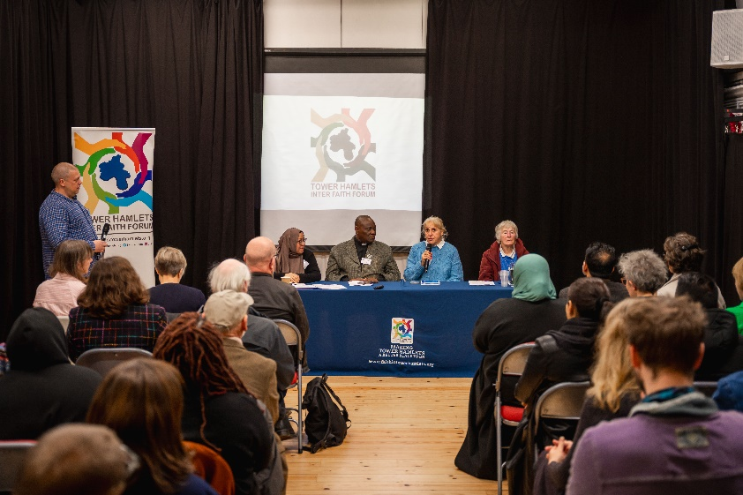
Featuring Sister Christine Frost (Neighbours in Poplar) and THIFF Steering Group members Sufia Alam, Rev James Olanipekun and Rev Georgina Stride (Shoreditch Tab), chaired by Dr Daniel Range, Coventry University

Real-life stories of housing insecurity
Sufia had many real-life stories to share based on conversations with women that attend the Maryam Centre at East London Mosque:
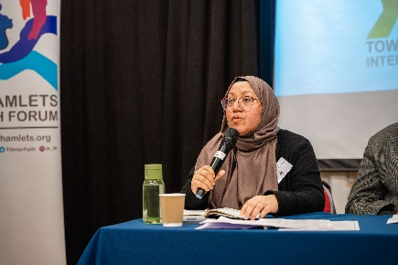

“Some of the horrific stories that I heard was really heartbreaking, like rats and mice being frequent visitors in their homes; one woman described how she had to put rodent control in because there wasn't anything being done by the housing and her children were frightened every night”

“Another’s daughter's chronic asthma was due to mould and damp that was continuous…despite her cleaning the house it was still very mouldy…. These are recurrent stories that we hear and it's terribly frustrating for us as a faith organisation because we can't help people with money or rehouse them or anything, but we can speak with the partners that are in the housing sector”

Reverend James quoted the Bible from Isaiah 32:18: “My people will live in peaceful dwelling places, in secure homes, in undisturbed places of rest.”

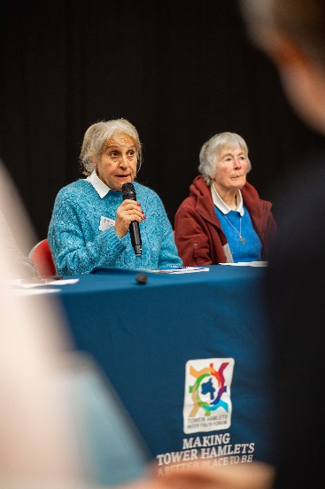
Reverend Georgina Stride detailed issue with overcrowding:
“We know one family, they've got four kids and in a two bedroom with her two cats. I don't know how she does it, and I suspect that's quite a common story for people in Town Hamlets, but just someone that's born and bred in Tower Hamlets, massive overcrowding, and our lovely visitors who come to our country who are also struggling, we try to help them.”

“We insured the (church) hall because at some points we were actually sleeping people in the church building.”

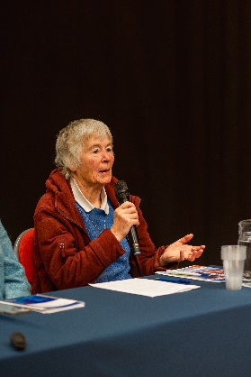
Sister Christine Frost spoke of high rents, overcrowding and issues for older residents:

“…. Four children and two adults. Their rent is £1,900 for the same flat I pay a social rent for So, bunk beds in the living room, you put pray, you sleep, you eat, children have no space to do homework – kids get bigger. They need more space…. a nineteen-year-old girl and a fifteen-year-old boy sharing a bed bunk bed in the one room…. surely that is not right”

(On older people living in flats) “most of the blocks along there do not have lifts. So, if you're on the fourth floor and you're older, and of course as life goes on you get older, and you get maybe less mobile…. you can either come up and you definitely can't go down. The only way you get out is in a box”

Why faith settings are uniquely positioned

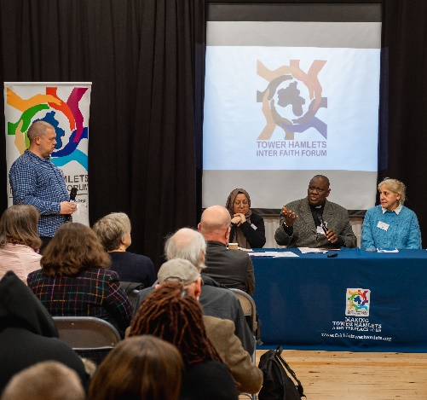
The panel described how the faith sector is uniquely positioned as they are: trusted, local, open long hours, seen as sanctuary and staffed by volunteers with deep community insight.

Reverend James highlighted:
“Every Sunday people stay in the church until 6pm just to be warm and safe.”

Sophia explained mosques historically served as sanctuaries:
“It breaks my heart that we cannot offer full sanctuary due to modern restrictions.”

Sister Christine reflected back on a time when the first British National Party (BNP) councillor was elected in the borough in the1990s – highlighting the power of faith organisations and social action:
“One thing I'm proud of maybe is that I was involved in a huge campaign at that point to get people to vote to get him out. And the churches got together and we organised.”

What faith groups are already doing

Discussion included how faith group are providing:
- Night shelters
- Renting church houses to refugees
- Emergency hotel stays for women fleeing violence
- Food provision to help families save money for heating
- Campaigning on affordable housing and community land trusts
- Signposting and emotional support
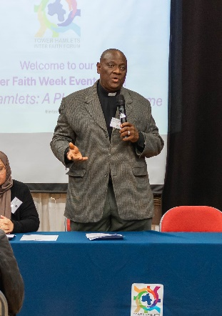
“We don't have big spaces, but the little space that we have, we make good use of. We collaborated with GrowTH and provided shelter. That's what we do in our church. People come, they sleep over, we give them dinner and breakfast…because it's a crisis, and it has to be done……we do it voluntarily, but we do it so well” – Rev James

“Mosques are places of sanctuary – we feel despair at times as we are not equipped so we can't give that sanctuary to people who are homeless. The mosque and I have organised money or provisions where we put women who are in those desperate situations in a hotel for a night at least until the offices are open. Some women are vulnerable or are in domestic abuse situations or had to flee home. We are a safe space and that's where people end up going.” – Sufia Alam

“Nobody wants to move out from a place they call home. They shouldn't have to. They want to be around the mosque that they go to pray in. They want to be in the community that supports them with child care” – Sufia Alam

Reflections from attendees

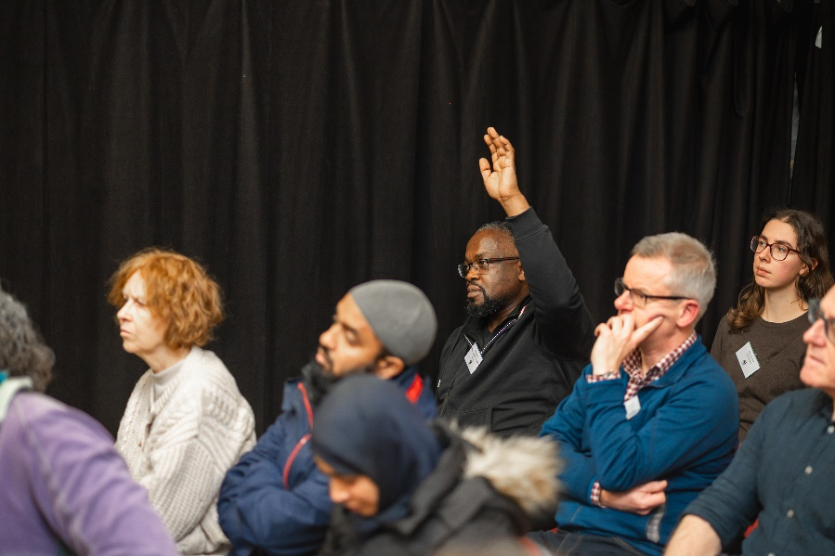

A GP described how overcrowding, damp, and unsafe housing in Tower Hamlets directly affect patients’ health, stressing that wider social factors like housing and employment matter as much as medical treatment. He promoted community-based support, including employment programmes, and encouraged collaboration on housing and homelessness.

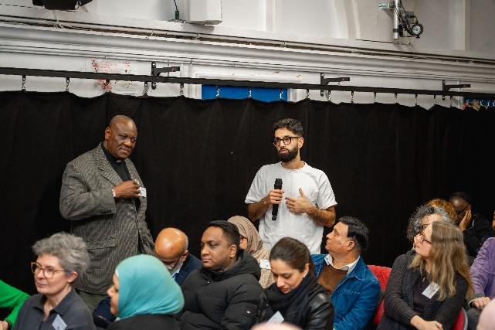
An advisor raised the dilemma of dealing with unsafe, unregulated housing: reporting landlords can make tenants homeless. Council staff acknowledged the moral tension but explained that such cases often emerge through tip-offs, that they try to ensure residents have somewhere to go, and that enforcement includes prosecuting landlords who breach licensing rules.

A representative from Housing Justice highlighted community-led solutions, such as the Refugee Lodgings Project, which connects refugees with hosts providing affordable rooms and social support.

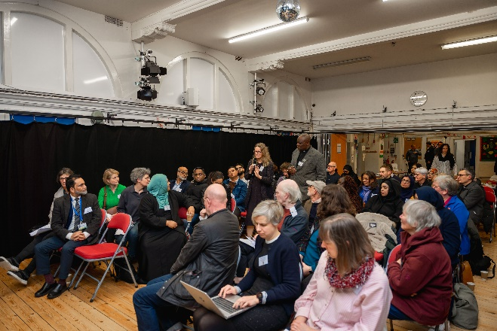
A resident then asked whether high housing costs are forcing young, skilled people to leave Tower Hamlets. Council staff confirmed this is part of a wider London affordability crisis and noted that while reforms to the private rented sector may help, deeper affordability measures are needed. They also mentioned emerging alternatives like co-living schemes and new forms of tenure to give young people more options.

THIFF co- chairs then closed the event, thanked attendees and emphasised:
- The urgency of the housing crisis
- The unique power of interfaith collaboration
- The need to continue sharing stories, data, and solutions
- The role of housing in issues like violence against women and girls, mental health, and social cohesion
“We need to work together. One day, may every home in our borough be a happy place.”

Connecting over refreshments

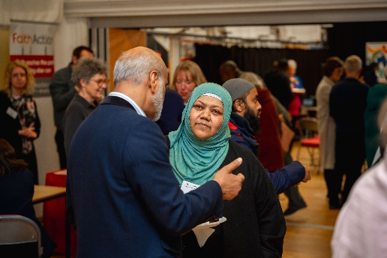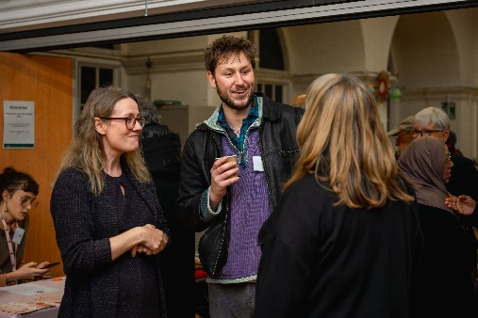

Attendees then enjoyed networking with each other, sharing news about their individual work and projects, gaining new connections and knowledge about other work locally.

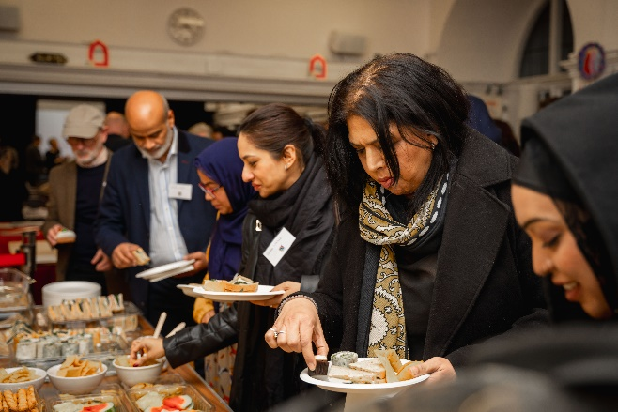

Attendees interacted with our stall holders, providing information on local organisations and their offer.

