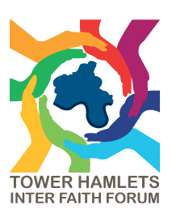
THIFF FORUM MEETING: Strengthening Faith Sector Engagement
Location: Feldy Centre
Date: Monday 23 March 2026
Time: 6-8pm

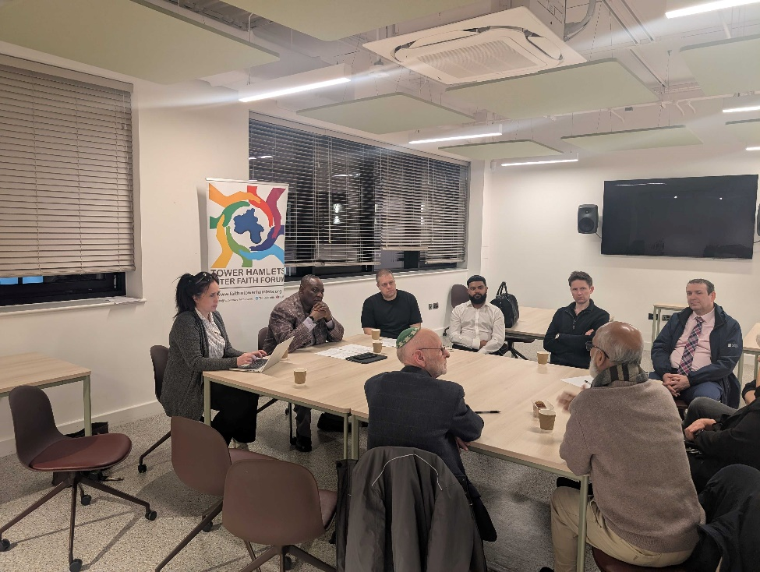

March’s THIFF Forum Meeting was a guided discussion, led by Dr Dan Range, Director of the Centre for Inclusive Evaluation. The discussion focused on engagement between faith communities in Tower Hamlets and statutory services such as the council and NHS, with particular attention to consultation, community cohesion, trust and representation.

1. Current engagement with the council and NHS
Participants felt that engagement has improved in some respects but remains inconsistent and often reactive rather than proactive. There are opportunities for faith groups to participate in consultations, but concerns remain about whether their contributions are genuinely listened to and acted upon.

The importance of making consultations accessible was emphasised, including using QR codes, different venues and more direct approaches to communities. Participants also felt that the council could do more to publicise the work of the Tower Hamlets Inter Faith Forum (THIFF) and communicate the value of faith communities' contributions.

2. Faith communities and community cohesion
A major theme was the role of faith groups in building cohesion and resilience across a highly diverse borough. THIFF was described as providing a way to bring communities together around shared local concerns such as housing, health and safer streets, rather than focusing on religious differences.

Participants highlighted examples including:
- Inter-faith discussions and "meet your neighbour" initiatives.
- Support for residents during the pandemic.
- Food and medicine deliveries to isolated residents.
- Open mosque and other faith-based events.
- Clothing and hot-meal distributions to rough sleepers.
- Work to counter division and hate.

There was a strong view that cohesive communities are better placed to respond collectively when crises or tensions arise.

3. What makes faith communities distinctive?
Participants identified several particular strengths of faith organisations:
- Reach and access: faith leaders and places of worship have established relationships with local residents.
- Trust: people may be more willing to discuss personal concerns with trusted faith leaders than with statutory services.
- Belonging: faith settings can provide a strong sense of family, community and belonging.
- Voluntary commitment: faith organisations often provide support outside conventional working hours.
- A whole-person approach: faith communities tend to consider people and communities more broadly rather than focusing on a single issue.
- Motivation to serve: religious beliefs can provide a strong motivation for charitable and community work.

Examples included faith leaders supporting health initiatives, encouraging vaccination, providing health checks and opening places of worship to people of all faiths and none.

4. Barriers to effective engagement
Several barriers were identified.

Accessibility: Some council offices and consultation arrangements can feel intimidating, particularly for people unfamiliar with formal institutional settings.
Awareness: Faith groups do not always know when consultations are taking place or why their contribution is particularly relevant.
Representation: Some faith groups are missing from THIFF and other engagement structures. Participants stressed that the existing forum should not claim to represent every faith community.
Capacity: Smaller organisations may lack the time and resources to participate consistently.
Continuity: Changes in council staff can cause relationships to be lost, meaning organisations have to rebuild connections repeatedly.
Trust: Historical experiences can create mistrust of statutory services.
One-way consultation: A recurring concern was that consultation can feel like an organisation is simply extracting information rather than entering into a genuine partnership.

5. Improving consultation
Participants argued that consultation should become more two-way, relational and collaborative.

Suggestions included:
- Providing clear feedback on what happened as a result of people's contributions.
- Explaining why a particular faith community's input is important.
- Using places of worship as consultation venues.
- Holding events in accessible local locations.
- Bringing different equality groups together.
- Providing recognition or modest financial compensation for people's time.
- Developing more opportunities for dialogue rather than simply collecting responses.
- Involving faith representatives earlier in the process, including co-design and co-production rather than presenting them with completed proposals.
- Maintaining relationships and continuity between council officers and community organisations.

A particularly strong message was that people need to feel valued, respected and listened to, rather than feeling that their participation is merely "box ticking".

6. Representation and diversity
Participants recognised that Tower Hamlets has a very diverse population, with many languages and a range of faith and non-faith communities. There was concern that relying on the "usual suspects" risks excluding less visible or less well-resourced groups.

The council was encouraged to take a more proactive approach to identifying and engaging communities that are not currently represented.

7. Council developments and commitments
Zaid ul-Islam, Senior Strategy and Policy Officer, Tower Hamlets Council, outlined several changes already being introduced following previous community engagement work, including:
- A rewards and recognition policy, including vouchers for participation.
- A resident engagement toolkit for council staff.
- A youth-focused engagement approach.
- A new consultation platform, Go Local, replacing Let's Talk Tower Hamlets.
- A "you said, we did" feature intended to show how residents' contributions have influenced outcomes.
- Work towards a more consistent approach to consultation across the council.

It was acknowledged that some of the suggestions raised during this session had not yet been implemented, but that the feedback would be taken back to council colleagues.

8. Faith Covenant and future engagement
The meeting also discussed the Faith Covenant, noting that Tower Hamlets had not yet signed one and that there was interest in pursuing this through FaithAction.

There was also support for greater senior political and council involvement in faith-community engagement, with the view that visible participation by senior representatives could demonstrate the importance attached to these relationships.

Overall conclusion
The discussion highlighted a desire to move from transactional consultation to genuine partnership between faith communities and statutory services. Faith organisations see themselves as valuable sources of community intelligence, trust, reach and practical support, but want their contribution to be recognised and acted upon.

The final point was that the Equality Hubs can provide an important mechanism for communities to raise issues and concerns, generating "community intelligence" that can inform future council strategies, consultations and service improvements.

