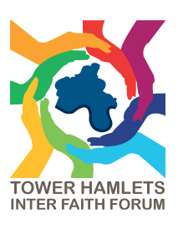
THIFF FORUM MEETING: Meet the Deputy Mayor
Location: Grocer’s Wing, Tower Hamlets Town Hall
Date: Tuesday 14 July 2026
Time: 6-8pm

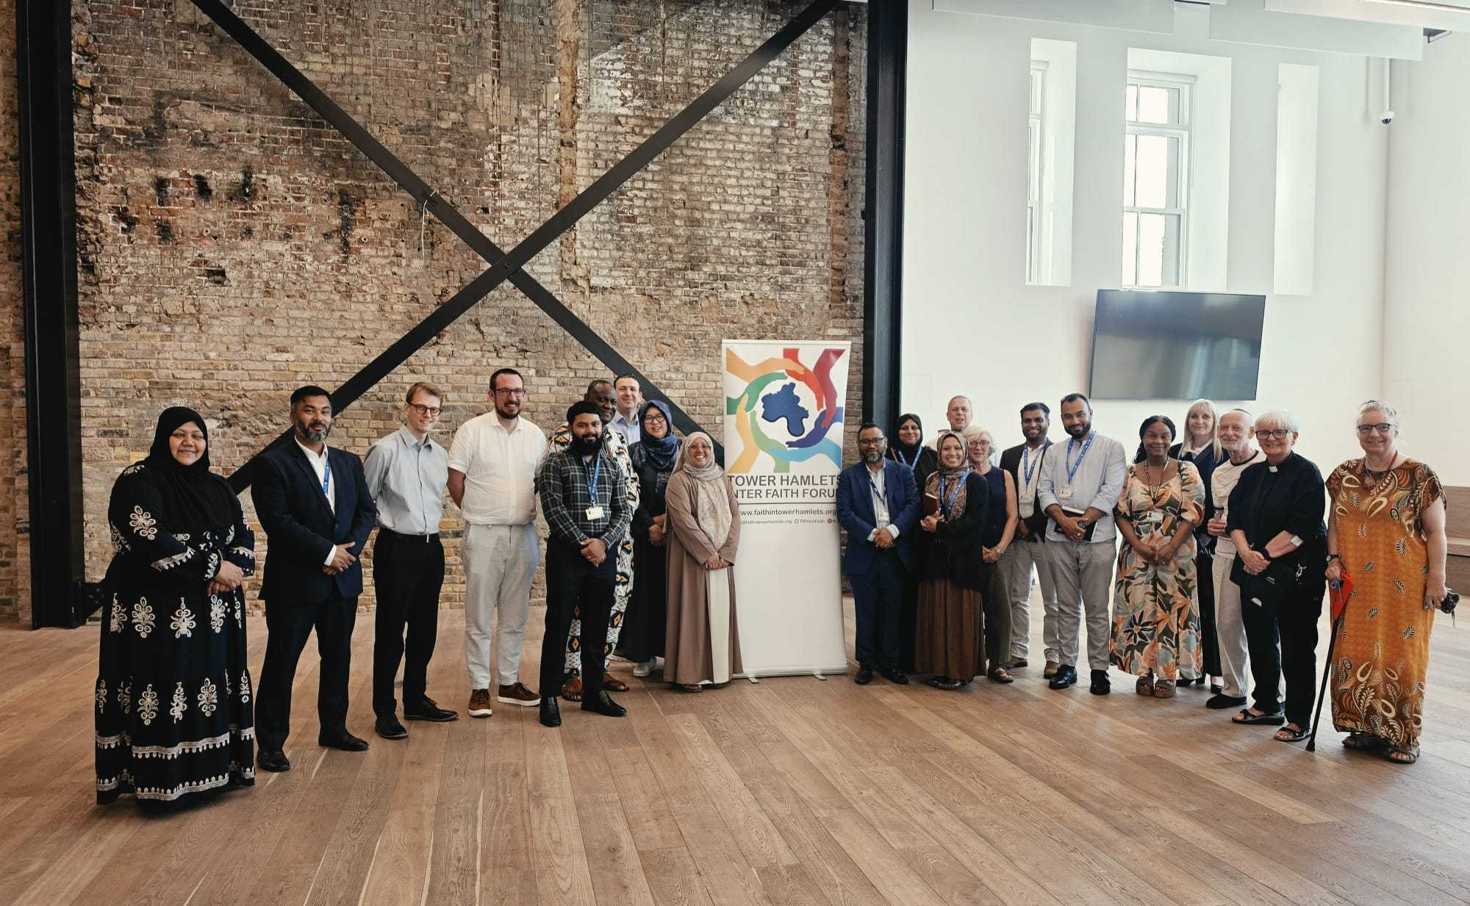

- THIFF’s work and achievements

Rev James Olanipekun and Sufia Alam, co-chairs of the Tower Hamlets Inter Faith Forum and Dr Dan Range, part of THIFF’s secretariat, presented on the THIFF Annual Report.

Dr Range noted that THIFF was an important convenor, connector and trusted source of information across the borough.

During the year it:
- Held four forum meetings and an Inter Faith Week event.
- Worked with at least 84 partner organisations, with the actual number likely higher.
- Supported three major project areas through the Equalities Hub.
- Ensured faith voices were represented in discussions around public health, equalities, community safety, housing and resilience.
- Produced around 100 social media posts and 25 newsletters.
- Distributed approximately 1,000 faith calendars.
- Maintained a Faith Map and Faith Directory.
- Worked with partners in response to local and national tensions, including far-right activity and rising racial and Islamophobic hate crime.

Community cohesion and responding to tensions
A significant part of THIFF’s role has been responding quickly when events threaten community cohesion. THIFF have been involved in opposing several marches and protests, including the UKIP march and the Jesus Christ March, as well as participation in the Mayor’s peace rally.
The emphasis was on demonstrating that different faith communities can work together, respond constructively to tensions and provide a united voice. THIFF also continues to monitor hate crime and build alliances between communities.

Future direction
THIFF is continuing to grow, with an expanding Steering Group and increasing involvement in borough-wide networks. Priorities include:
- Strengthening relationships with the council and Equalities Hub.
- Developing the borough’s cohesion strategy with faith groups.
- Ensuring residents’ concerns shape future forum meetings.
- Refreshing THIFF’s manifesto to reflect changes in the borough.
- Continuing involvement in major borough events.
- Maintaining a strong faith voice in strategic discussions.

- Deputy Mayor’s contribution
THIFF were immensely grateful to be joined by Cllr Maium Talukdar, Deputy Mayor and Cabinet Member for Tackling Inequality and the Cost of Living, Improving Customer Services and Voluntary Sector Engagement.

The Deputy Mayor expressed strong support for THIFF and the partnership between the council and faith communities. He highlighted several opportunities for greater collaboration, including:
- Better promotion of council grants to faith organisations.
- Exploring an annual community BBQ using green spaces at faith settings.
- Establishing Faith Awards to recognise contributions by faith communities.
- Holding a Faith Forums Open Day at the Town Hall, covering employment, community safety, council services and support available to faith organisations.
- Continuing direct dialogue between THIFF and council officers.

3. Issues raised in the Q&A
Participants at the meeting were able to put questions to the Deputy Mayor. Several important community issues were identified:

- Youth mental health and loneliness, particularly following the closure of youth centres and difficulties accessing remaining services.
- Improving young people's access to employment support, including the possible restructuring and relaunch of the Work Club.
- Greater investment in mental health first aid, recognising that faith leaders can often be among the first people approached during a crisis.
- Encouraging third-party reporting of hate crime, particularly because under-reporting can affect understanding of the scale of the problem.
- Access to grants for faith organisations undertaking work addressing health inequalities.

4. Other updates
The meeting also received updates on:

- A THCVS project involving voluntary-sector organisations and protected-characteristic communities, addressing domestic abuse, mental health and prevention.
- An upcoming Faith Health Fair focused on Black African and Caribbean communities.
- A Women’s Health Fair at the Maryam Centre, addressing health inequalities affecting Muslim women.

