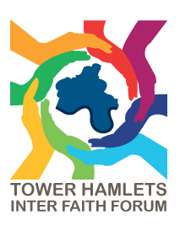
THIFF FORUM MEETING: Have Your Say on Voluntary and Community Sector Grants in Tower Hamlets
Location: Tower Hamlets Town Hall
Date: Tuesday 15 September 2026
Time: 6-8pm

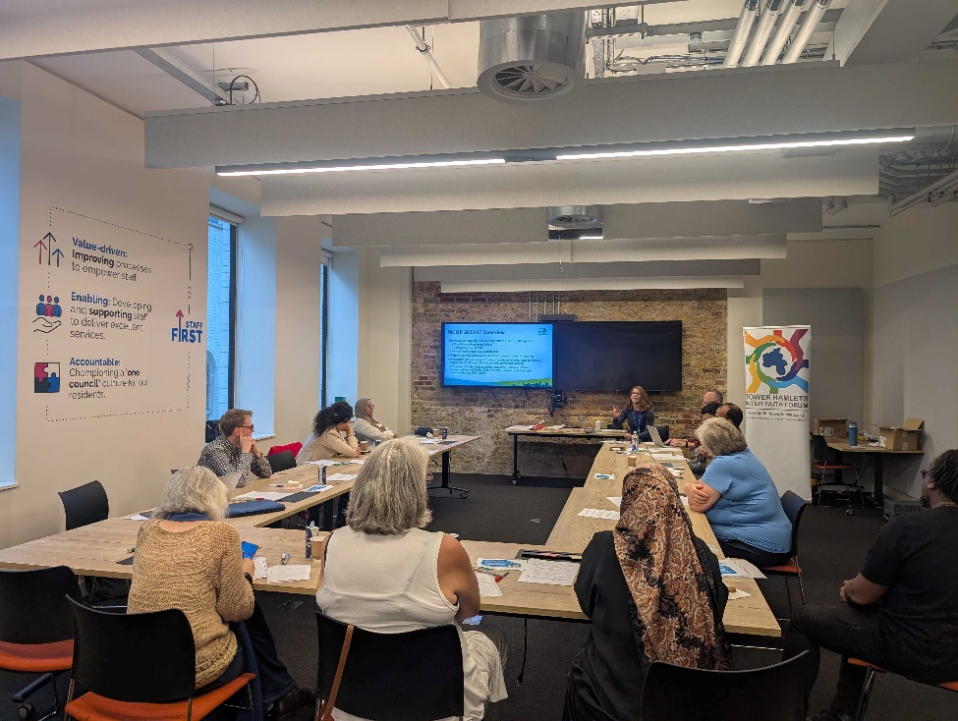

September’s THIFF Forum meeting saw participants take part in a consultation with the Corporate Strategy and Communities team at Tower Hamlets Council to discuss the next phase of the Voluntary and Community Sector Grants programme.

Lucy Hughes, Senior VCS Development Officer acknowledged that the borough has a large and diverse VCFSE sector, supporting the community in ways that statutory services don’t. The current Voluntary and Community Sector Grants programme has supported 100 organisations to do this. However, the council has also acknowledged that the previous programme had issues that the council wanted to address and make sure the new round of funding accurately met the needs of the VCFSE sector.

Participants were able to discuss the 5 areas of focus for the new funding, making suggestions as to what funding for these areas might look like and how VCFSE organisations could support in these areas, as well as highlighting strengths and challenges of the previous programme and what groups would like to see carried on or improved.

Updates
Sufia Alam, co-chair of THIFF, highlighted a Visit my Mosque at East London Mosque on 19th September.
Marlene Botha from London City Mission highlighted their Operation Forgiveness programme, teaching children about the ripple effects of knife crime. It is an early intervention programme targeting children before secondary school and they would like help to get into schools.

